Property Management Plan

for

Edwards Wetland Nature Reserve

Date of Report: | August 12, 2021
Prepared for: | Rideau Waterway Land Trust
Author/s: | Alyssa Fiedler and Caroline Spang  RWLT Conservation Biologists
Reviewer: | Morgan Roblin,  OLTA Conservation Science Manager
Version: | FINAL – Approved Aug 12, 2021

Acknowledgements and Disclaimers
This Property Management Plan was generously funded by the Ontario Land Trust Alliance (OLTA) through their Species at Risk Action Fund.
This Property Management Plan was prepared by Caroline Spang, Conservation Biologist, Rideau Waterway Land Trust with guidance from Morgan Roblin, Conservation Science Manager, OLTA.

Cover illustration provided by Alyssa Fiedler, RWLT Conservation Biologist.

For further information, please contact:
Rideau Waterway Land Trust
info@rwlt.org
613-305-3507
www.rwlt.org

Contents
1 Mission Statement 5
1.1 Vision, Mission, and Guiding Principles 5
1.2 General Guidelines for Management Plan 5
1.3 Site Information used for this Management Plan 5
2 Property Management Plan Summary 6
2.1 Property Information 6
2.2 Biodiversity Values 8
2.3 Conservation Targets and Threats 9
2.4 Conservation Management Goal and Objectives 10
2.5 Five-year Budget Summary 10
3 Background 12
3.1 Purpose of the Management Plan 12
3.2 Rideau Waterway Land Trust’s Conservation Efforts 12
3.3 Edwards Wetland Management Goals 14
3.4 Property Description 14
4 Property Management 17
4.1 Historical Land Use 17
4.2 Acquisition History 18
4.3 Current Management 18
4.4 Future Acquisitions 19
4.5 Stewardship 19
5 Baseline Inventory Summary 20
5.1 Physical Features 20
5.2 Biological Features 21
5.3 Conservation Context 24
5.4 Landscape Context 26
6 Conservation Target Analysis 26
6.1 Forests 26
6.2 Cattail Wetland 29
6.3 Gray Ratsnake 30
6.4 Other Targets 31
7 Threats 31
7.1 Invasive Non-Native/Alien Plants and Animals 31
7.2 Hunting and Collecting Terrestrial Animals 31
7.3 Utility and Service Lines 31
7.4 Motorized Vehicles and Associated Infrastructure 31
7.5 Garbage and Solid Waste 32
7.6 Climate Change 32
8 Management Goal, Objectives and Actions 33
8.1 Management Goal 33
8.2 Stewardship Actions 34
8.3 Stewardship Cost Summary 37
9 Management Plan Review 40
10 References 40
11 Appendices 42
11.1 Appendix B: Monitoring Report Template 42
11.2 Appendix E: Restrictions Upon Use or Disposition Of Edwards Wetland 48

List of Figures
Figure 1: Regional Locator Map 7
Figure 2: Top - Map of RWLT area of operation w.r.t. Edwards Wetland; Bottom – Close-up of Edwards Wetland and nearby RWLT properties in Rideau Lakes area 13
Figure 3: Satellite Imagery of Edwards Wetland 15
Figure 4: Protected Lands and Provincially Significant Areas 17
Figure 5: Improvements and Structures 19
Figure 6: Vegetation Communities 22

List of Tables
Table 1: Edwards Wetland Property Summary 14
Table 2: Legal Description of Edwards Wetland Parcels 14
Table 3: Vegetation Communities Identified on Edwards Wetland 22
Table 4 Species of Conservation Concern - NHIC 23
Table 5: Invasive Species Recorded on Edwards Wetland 23
Table 6: Target Viability Assessment for Forests 27
Table 7: Target Viability Assessment for Cattail Wetland 29
Table 8: Target Viability Assessment for Gray Ratsnake 30
Table 9: Planned Stewardship Actions 34
Table 10: Cost breakdown to implement management actions 37

Mission Statement

Vision, Mission, and Guiding Principles
The Rideau Waterway Land Trust’s (RWLT) vision is that “Nature has a future because our communities care.” Their mission is “To preserve important natural lands and habitat in the Rideau Corridor and foster a healthy future for our communities.”
RWLT uses the following guiding principles:
- We focus on the preservation of important land that supports plants, animals, and clean water.
- Our actions are inclusive and for the benefit of the community.
- We welcome the participation of those who appreciate the importance of nature.
- We strive for the right balance between access and the protection of conservation values.
- We partner with other organizations on mutually beneficial activities.

General Guidelines for Management Plan
- The primary objective is the conservation of biodiversity.
- Use of properties owned and managed by the RWLT will be restricted to activities that are consistent with its mission statement, guiding principles and property-specific guidelines.
- Signage will be carefully planned to encourage only compatible activities. Signs at suitable access points will indicate:
  - Property ownership
  - Emergency contact name and telephone number
  - Trespassing is prohibited and access is restricted.

Site Information used for this Management Plan
This Management Plan is based on:
- Baseline inventory prepared in October 2003 by Simon Lunn
- Monitoring reports from 2006, 2009, 2013, and 2020
- Property information collected during site visits by RWLT staff in 2020 and 2021

Property Management Plan Summary

Property Information
Edwards Wetland is composed of two adjoining parcels of land located just outside of Portland, ON, at the junction of Highway 15 and Cove Road. The larger 49-hectare parcel (Figure 1, ‘Wetland Parcel’) consists of a wetland marsh surrounded by a healthy buffer of mixed-age deciduous forest, and an abandoned limestone quarry. A smaller interconnected 8.5-hectare parcel (Figure 1, ‘Shoreline Parcel’), which has a connection to Big Rideau Lake, consists of a fairly mature, undisturbed deciduous forest typical of the Great Lakes/St. Lawrence Forest Region in this part of eastern Ontario. The forest and wetland play an important role in sustaining the biodiversity of the area, while the forest edges and open areas provide habitat for the Threatened Gray Ratsnake population of the Frontenac Arch.
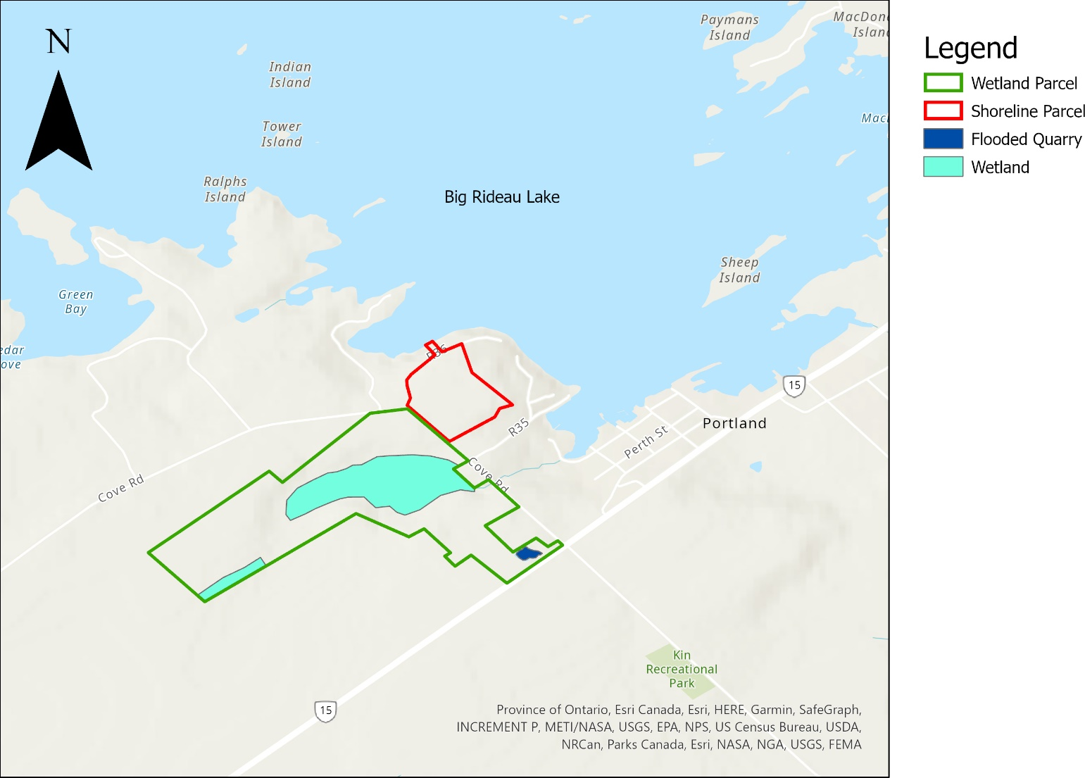
Figure 1: Edwards Wetland

Location
Edwards Wetland is located in the Township of Rideau Lakes, in the Geographic Township of Bastard. It is just west of the village of Portland, ON. For the location of Edwards Wetland relative to other RWLT properties in the Township of Rideau Lakes, see Figure 2 below.
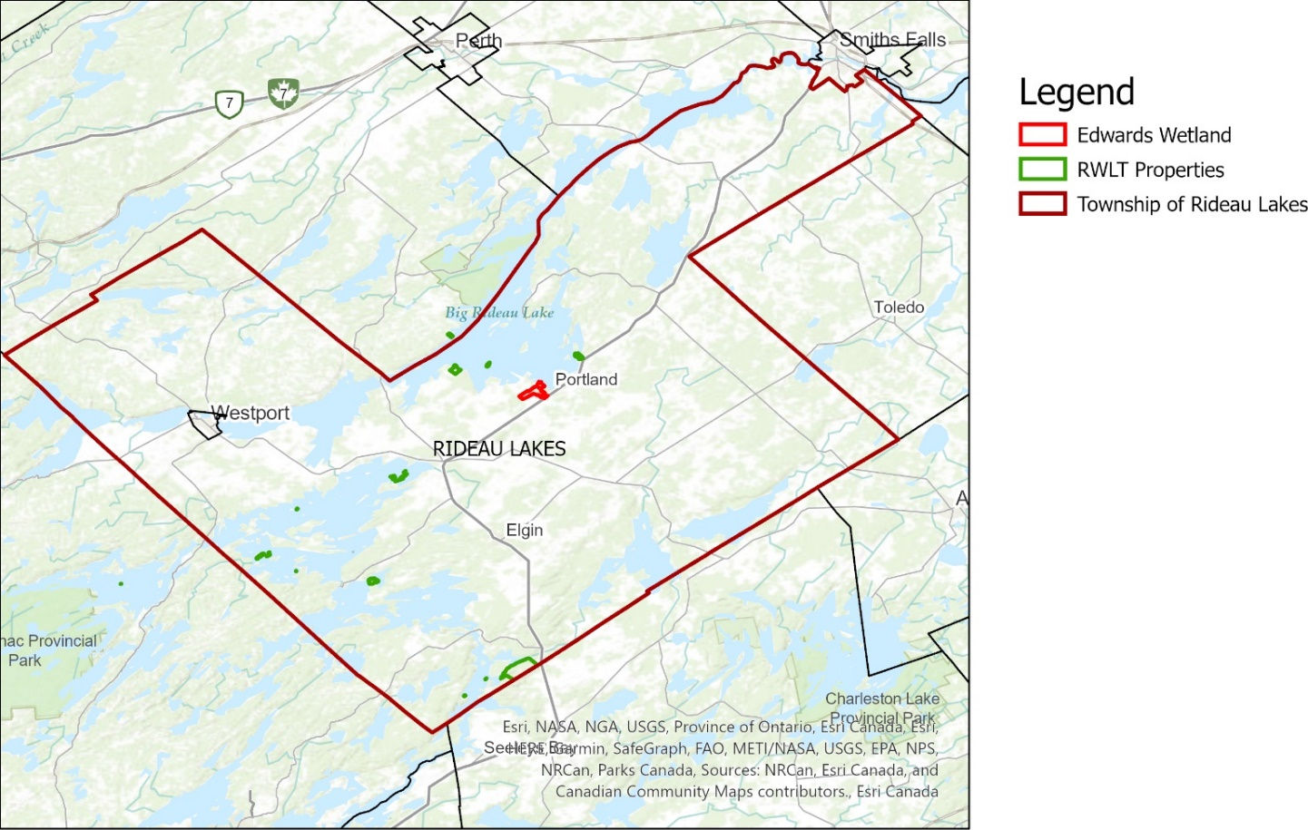
Figure 2: Regional Locator Map

Property Area
Edwards Wetland is 57.45 hectares and is made up of two parcels separated by Cove Road.

Securement Type/ Year
Property Identification Number (PIN) | Assessment Roll Number | Area (hectares) | Year Acquired | Acquisition Type | Purchase Price
44124-0077 LT | 08-31-831-036-55106 | 8.46 | 2014 | Donation | N/A
44124-0113 LT  44124-0119 LT | 08-31-831-051-16705 | 48.99 | 2014 | Donation | N/A

Key Local Partners
Key local partners in the management of Edwards Wetland include:
- Ducks Unlimited Canada – a past project on the property includes installation of a concrete dam at the outflow from the wetland located on the Wetland Parcel. The agreement with DUC has since expired, but they are still an important source of information, and willing to work with us on any future projects that might be mutually beneficial
- Rideau Valley Conservation Authority – as the CA in charge of the Rideau River watershed, the RVCA is an important source of information, advice, and a potential partner on future projects. They are also the regulatory authority on anything involving changes to the watercourses on the property.
- Peter Hannah – as current RWLT Board Chair, and neighbor to the Shoreline Parcel, Peter plays an important role in noting any changes or issues on the property as well as adding personal observations of flora and fauna during the year
- Richard Nasmith – a neighbor to the west of the Wetland Parcel, Richard is enthused about assisting the RWLT with keeping watch over Edwards Wetland for trespassing hunters and was an invaluable source of information on the history of the property and changes in the last 20 years

Biodiversity Values
Edwards Wetland is home to a wide range of species of flora and fauna, including a number of species at risk. A brief summary can be found below, with further details in Section 5.2: Biological Features, found on page 19.
 | Number of Species | Comments
Amphibian | 5 | Including one federally threatened species
Bird | 35 | Including 9 forest interior species and
Invertebrate | 1 | Including one species at risk
Mammal | 8 | Including three bat species, red fox and southern flying squirrel
Plant | 38 | Including 14 nonnative species and one species at risk
Reptile | 3 | Including three species at risk
Tree/Shrub | 39 | Including two nonnative species and one species at risk

Conservation Targets and Threats

Conservation Targets/ Overall Viability Assessment
Target | Overall Viability
Forest | Fair | All indicators are in relatively good condition. Concerns about the health of the forest relate to the general lack of amphibians during monitoring visits, as well as the presence of at least nine invasive species. As well, the surrounding landscape is primarily nonnatural, with the potential for increased development in the future.
Cattail Wetland | Good | Most indicators are in good or very good condition. The major concerns stem from the lack of recent records of wildlife using the wetland, and the invasion by purple loosestrife
Gray Ratsnake | Unknown | The nestboxes have only been installed for less than a year, and will likely take a few years of monitoring to determine the status of the Gray Ratsnake on the property

Highest Threats
Target | Top Two Threats
Forest | Invasive Species  Climate Change | At least nine invasive species are already present in the forest target, and climate change is likely to increase the number and success of new and existing non-native invaders.
Cattail Wetland | Invasive Species  Climate Change | Purple loosestrife is widespread in the wetland, and new invaders are likely under climate change scenarios. As well, a changing climate may interfere with the existing hydrological connections between the target wetland and neighboring properties, potentially leading to a change in size or type of wetland.
Gray Ratsnake | Motorized Vehicles  Climate Change | Motorized vehicles are among the biggest causes of Gray Ratsnake mortality overall. This is a threat both on the roads surrounding Edward’s Wetland, as well as from trespassing ATVs on the snowmobile trail.  Climate change may result in a variety of new challenges for the already threatened Gray Ratsnake population, including the potential for novel diseases, and changes in hibernation sites that could lead to overwintering mortality.

Conservation Management Goal and Objectives

Goal
RWLT intends to maintain the ecological integrity of Edwards Wetland. This nature reserve has extensive forest and wetlands and supports many species at risk. It is our goal to ensure its persistence as well as the species it supports into the future. This is especially important considering that fact that the surrounding landscape is increasingly developed, leaving Edwards Wetland to serve as a refuge to the forest flora and fauna.

Objectives
RWLT’s objectives include:
- Keep invasive species from spreading beyond 2021 limits
- Perform targeted studies to better record the species at risk currently making use of the property
- Increase the number of Gray Ratsnakes breeding on the property to 2 nests/year within 5 years

Five-year Budget Summary
The total cost to implement this management plan is $21,113.15 over five years or approximately $4,200 per year. All cost calculations are based on rates from 2021 and are subject to change.

Urgent Actions
Description |  | Cost | Frequency
Property Maintenance | Perform tasks as needed to keep property in good condition ecologically and functionally  - Remove invasive species  - Remove unauthorized construction | $658.00/year | Annually
 |  | Total Over 5 Years | $3,290.00

Necessary Actions
Description |  | Cost | Frequency
Property Taxes and Insurance | Property taxes and insurance  - Register property under CLTIP CCL  - Maintain insurance policy  - Pay property taxes if the entire property is not eligible under CLTIP  - Liaise with municipalities/MNRF/MPAC | $1175.63/year | Annually
Property Signage | Maintain and replace signage as needed, assuming 10 year replacement period | $240.00/ 10 years | Every 10 years
Annual Monitoring | - Conduct annual monitoring visit and complete form  - Where appropriate, this visit can also include the following:  - Invasive species inventory  - Long term snake monitoring  - Record incidental SAR  - Record all species encountered | $658.00/year | Annually
Bi-Annual Monitoring | Bi-Annual Monitoring (in addition to annual monitoring)  - Breeding Bird Surveys  - Amphibian Surveys  - Marsh Monitoring (where possible)  - Vernal Pool Surveys | $658.00/2 years | 2021, Every 2 years
Reports and Database | - Draft any invasive species or SAR reports  - Update species database  - Plan visits | $756.00/year | Ongoing
Partner Liaison | - Keep in contact with DUC, snowmobile club, RVCA | $216.00/year | Ongoing
 |  | Total Over 5 Years | $15,793.15

Beneficial Actions
Description |  | Cost | Frequency
Ratsnake Nest Boxes | Perform yearly monitoring for use of boxes and refill with additional nesting materials, in conjunction with EcoTec Inc. | $406.00/year + cost of materials | Annually
 |  | Total Over 5 Years | $2,030.00

Background

Purpose of the Management Plan
Rideau Waterway Land Trust acquired the 57.45-hectare Edwards Wetland property in 2014 as a bequest from Elizabeth Edwards. A third parcel on Sherwood Point was bequeathed to the RWLT at the same time by Ms. Edwards but is not covered under the scope of this management plan. All three parcels were subject to a Conservation Easement Agreement (CEA) between the RWLT and Ms. Edwards. This CEA is currently “suspended” as the RWLT holds the title to the land but will remain in place and be enforced in the event that the property is ever sold or transferred.
Information on Edwards Wetland was found in a Baseline Inventory from 2003 (Lunn, 2003), as well as several monitoring reports completed over the years, primarily by Simon Lunn, a retired Biologist. RWLT has not previously completed any management or stewardship plan for this property.
The scope of this management plan is place-based, focused on Edwards Wetland. This management plan will describe how the organization will govern this ecologically significant property on the shores of Big Rideau Lake for the next five years.

Rideau Waterway Land Trust’s Conservation Efforts
There is no clear documentation of the process used by the RWLT to decide to accept first the donation of the CEA, and later the fee simple title, to Edwards Wetland. However, the property did meet many of the land trust’s land acquisition criteria at the time (RWLT Board of Directors, 2008). At the time of the CEA donation, the RWLT had few properties, and those that it owned were mainly small. Edwards Wetland is fairly close to Red Rock, a property acquired by RWLT in 2001. The addition of the two Edwards Wetland parcels, as well as Sherwood Bay, significantly increased the amount of land under the protection of the RWLT. In particular, Sherwood Bay and the Shoreline Parcel of Edwards Wetland protect important natural shoreline on Big Rideau Lake. This contributes to the ecological health of this popular lake and protects natural viewscapes on the main Rideau Canal channel.
The property also fits perfectly into the RWLT’s updated acquisition criteria (Spang & Fiedler, 2021). Along with its cultural and ecological value, Edwards Wetland lies within one of the RWLT’s two targeted areas for acquisition and forms a cluster of protected lands with four other RWLT properties: Red Rock, Sherwood Bay, Lady Kingsmill Nature Area, and MacDonald’s Island Wetland.
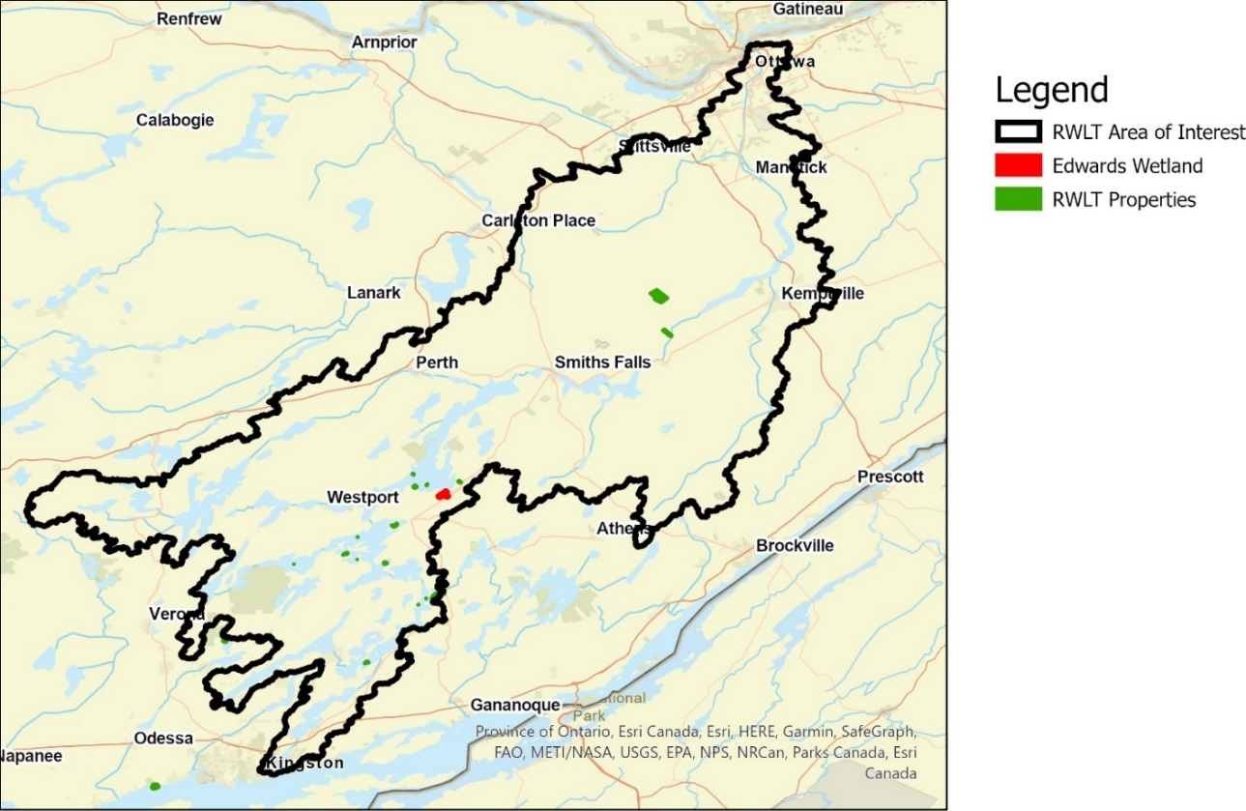
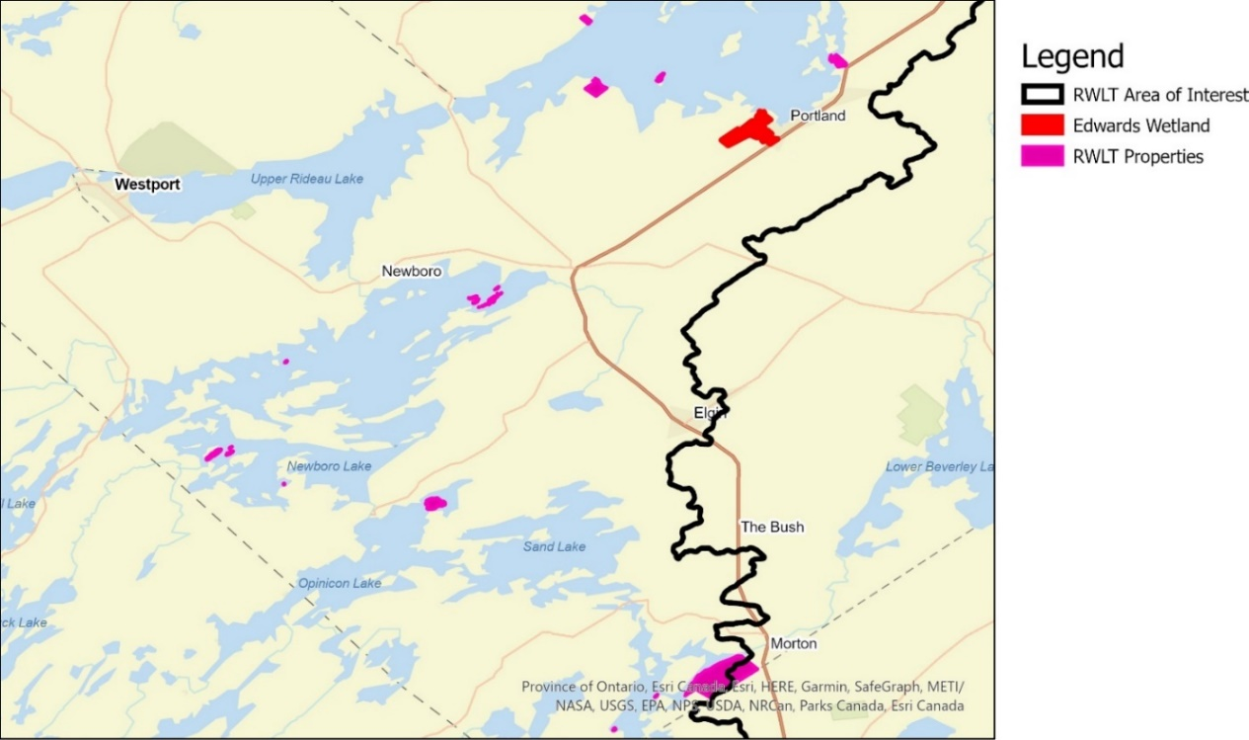
Figure 3: Top - Map of RWLT area of operation w.r.t. Edwards Wetland; Bottom – Close-up of Edwards Wetland and nearby RWLT properties in Rideau Lakes area

Edwards Wetland Management Goals
It is RWLT’s goal to maintain the ecological value of the property, guided by the following vision:
A thriving community where birds flutter among the branches of the forest, frogs call from the wetland, and ratsnakes slither and bask on the limestone plateau.
The long-term vision for the property is to steward and maintain the health of conservation targets, reduce or eliminate threats, and support species at risk.

Property Description
Table 1: Edwards Wetland Property Summary
Property Owner | Rideau Waterway Land Trust
Nearest Major Centre | Portland, ON
Directions | Take Highway 15 north from Kingston, turn onto the left shoulder of the road about 75m before the intersection with Cove Rd. Park in front of the metal gate at the entrance to the snowmobile trail. Alternatively, park at the Country Roads Community Health Centre at the corner of Cove Rd & Hwy 15
Coordinate Reference | 44.693402, -76.195495 (snowmobile access gate onto the property)
Elevation | Highest point: 153m ASL  Wetland: 138m ASL
Surface Area | 57.45 hectares
Conservation Authority | Rideau Valley Conservation Authority
Watershed | Big Rideau Lake – Portland Subwatershed
EcoDistrict | Smith’s Falls 6E-11
MNRF District | MNRF’s Southern Region, Kemptville District.  Address: Unit 1, 10 Campus Drive, Kemptville, ON K0G 1J0  Phone: 613-258-8204

Legal Description
Table 2: Legal Description of Edwards Wetland Parcels
Assessment Roll Number | Property Identification Number | Legal Description | Year Secured
08-31-831-036-55106 | 44124-0077 LT | Bast Con 2 PT Lot 20 Rideau Lake | 2014
08-31-831-051-16705 | 44124-0113 LT  44124-0119 LT | Bast Con 2 PT Lot 21, PT Lot 22, RP 28R558 Parts 1 to 3, RP 28R4641 Parts 1 2 4 and 5 | 2014

Description of Property Perimeter Boundaries
The larger Edwards Wetland Wetland Parcel is a highly irregular shape. It is bounded to the southeast by Highway 15, from the intersection with Cove Rd and continuing for ~260 m. The boundary then veers northwest for ~600 m, with numerous sharp angles around adjoining parcels, including an old schoolyard, agricultural fields, and forest. It then turns southwest and continues in a straight line for ~645 m along the boundary of adjacent agricultural fields and a large wetland. After running northwest for ~260 m through the forest, the boundary then goes northeast for ~1km, with a sharp jag ~70 m southeast in the middle. At this point, the boundary mainly follows Cove Rd, first ~125m almost due east, and then ~800 m southeast back to the starting point. This section of the property along Cove Rd has several residential lots cut out of it. The boundary, with some exceptions mainly along the road, is mostly unmarked, with old remnants of cedar fence found in a few locations and a newer fence along a portion of the north-western boundary.
The smaller Shoreline Parcel is primarily bounded by Cove Rd on the southwest side (~220 m) and R36, an unpaved private road, on the northwest side (~600 m). The boundary then runs ~140 m south through the forest and veers southeast for ~200 m. The southwest boundary runs for ~270 m until it connects back to Cove Rd. There is also a small rectangular section on the northern side of R36 that extends down to the shores of Big Rideau Lake.
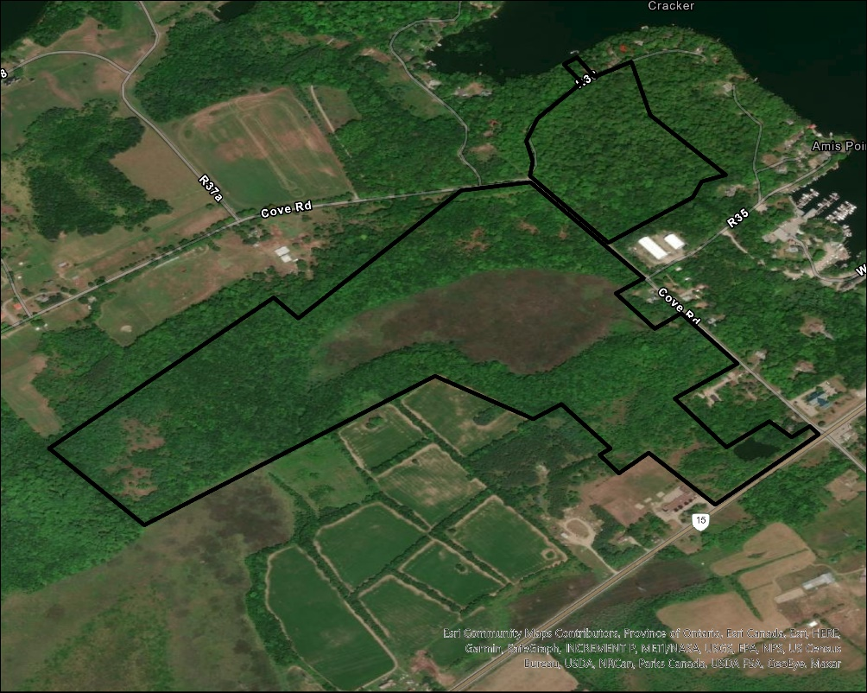
Figure 4: Satellite Imagery of Edwards Wetland

Site Designations
There are no PSWs, ANSIs or other designated property types present on Edward’s Wetland.

Agreements (leases, encumbrances, etc.)
In the northeast corner of the Wetland Parcel, there is a hydro easement corridor that runs parallel to Cove Rd and bisects the property for ~165 m. There is also a right-of-way that runs along the edge of the Shoreline Parcel for ~ 375 m. This contains R36, the private road that services the shoreline properties in this area, as well as the related utility services. At present, there are also discussions underway regarding the installation of telecommunications equipment to facilitate upgraded services to homeowners along R36.
The Rideau Ridge Riders snowmobile club has been allowed to use the trail on the west side of the Wetland Parcel for many years, since the previous owner, although no official written agreement can be found between the club and the RWLT. This is something that should be addressed soon, as well as clarifying the responsibilities that each party agrees to take on.
At the outlet from the large wetland on the Wetland Parcel, there is a concrete dam built as part of an agreement between the previous property owner and Ducks Unlimited Canada (DUC). This agreement expired and there has been no monitoring or management by DUC since 2016.
The property was donated to the RWLT as a CEA in 2004 through Environment and Climate Change Canada’s Ecological Gifts Program. It is registered as EcoGift #ON220. As the recipient of an Ecological Gift, RWLT is required to uphold recipient responsibilities under the federal EGP. This includes ensuring that the CEA is enforced, creating a Baseline Documentation Report, and maintaining current land-use consistent with the original objectives of the Ecological Gift. The penalty for an unauthorized disposition or change in use of an Ecological Gift is a federal tax equal to 50% of the current fair market value of the land (Environment and Climate Change Canada, 2021).
The property is also registered under the Conservation Land Tax Incentive Program (CLTIP) as a Community Conservation Land (CCL). The CCL category broadens the range of properties owned by Conservation Authorities or like-minded organizations that are eligible for a property tax reduction. No use that would be detrimental to the natural heritage values of the property is permitted on a property registered under CLTIP (Ontario Ministry of Natural Resources, 2021). RWLT is required to reapply annually for properties registered in this program.

Adjacent Land Use and Cultural Elements
The properties directly surrounding Edwards Wetland are mainly used for agricultural and residential purposes. Farms make up the majority of the land west of the property, while to the east is the village of Portland, ON. A small spur of the Shoreline Parcel connects to Big Rideau Lake, providing a bridge between shoreline and inland habitat.
The Cataraqui Trail runs about 1.3 km southeast of the property. As well, about 1 km east, the Rideau Valley Conservation Authority owns and manages the Portland Conservation Area on the shore of Big Rideau Lake.
Several Provincially Significant Wetlands are located near the Edwards Wetland property (Figure 5). Large portions of the Big Rideau Lake – Bass Lake Wetland Complex lie within 5 km of the property, as well as part of the Big Rideau Lake Wetland Complex. Many unevaluated wetlands also lie within the surrounding landscape.
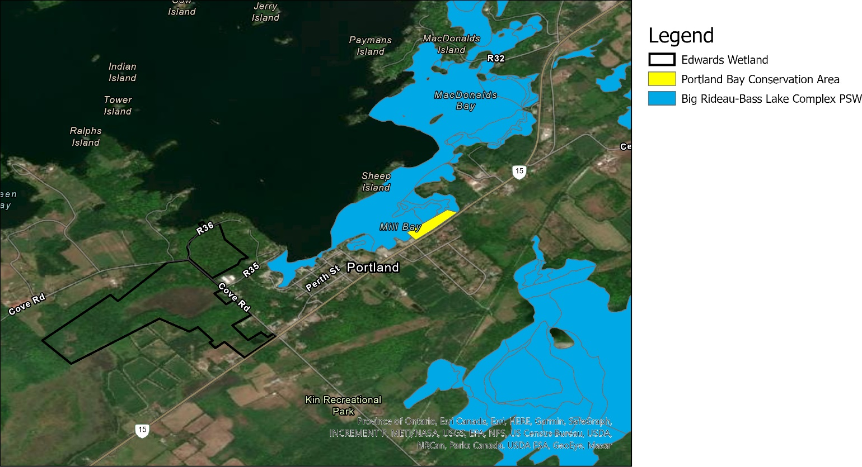
Figure 5: Protected Lands and Provincially Significant Areas

Property Management

Historical Land Use
Edwards Wetland is part of a much larger parcel that was originally granted by the King of Great Britain to a Captain for military service. This property was later sold to the Bolton family, who started the farmstead and quarry that can still be seen on the property today. The property was mainly used as a wood farm, supplying the lumber mill in Portland. Later, parts of the property were transitioned to agricultural use under the Bolton family, and agricultural use was intensified after the property was sold to the Hull family. The portion that now makes up Edwards Wetland was used for maple syrup and/or maple sugar production, but the sugarbush was not large enough to sustainably support a profitable operation for long. As there are few maples left in the area of the sugar shack ruins, the trees were likely cut and used as firewood (Nasmith, 2021). Little is known regarding the history of the long abandoned limestone quarry located in the southern corner of the Wetland Parcel.
Eventually, Edwards Wetlands passed into the hands of the Edwards family, while other sections of the property were sold to others, including current neighbour Richard Nasmith. Under Ms. Edwards, the property was used for passive recreation by the family, as well as for skiing by children of the neighbouring school and snowmobiling by the Rideau Ridge Riders club.
In recent history, the biggest changes on the Edwards and Nasmith properties have been changes to the wetlands due to beaver activity. While the land was being intensively farmed, beaver dams would likely have been removed to avoid flooding the fields. However, around 50 years ago (estimated by Mr. Nasmith), the farmers must have stopped removing the dam near the outlet onto the Edwards property. When Mr. Nasmith purchased the land 30 years ago, the wetland on his property was full of dying soft maple, which would only last around 20 years after being flooded. The wetland at that time had significant open water but has since mostly filled in with vegetation (cattails), as has the wetland on Edwards Wetland. The beavers have also led to deforestation on Edwards Wetland, as their population has increased in recent years after trapping stopped about 25 years ago.

Acquisition History
A CEA between Elizabeth Gordon Edwards and the Rideau Waterway Land Trust was registered on title for Edwards Wetland on September 30, 2003. This CEA was donated by the property owner, Ms. Edwards, to ensure the continued natural and environmental integrity of the property. In 2013, Ms. Edwards passed away and bequeathed the property to the RWLT. As there were no funds attached to this bequest, the RWLT contacted Environmental and Climate Change Canada for permission to sever a 1.09-hectare piece of the Sherwood Bay property that could be sold to raise the necessary stewardship funds. This application for a disposition of part of the property was denied. However, to protect the property from a possible court challenge to the CEA, the RWLT took possession of Sherwood Bay and Edwards Wetland on December 11, 2014.

Current Management
Since the acquisition of the fee simple title in 2014, Edwards Wetland has primarily been managed as a nature preserve, with minimal human interference or disturbance. Public access is limited to permitted snowmobilers only during the winter months, with no public access allowed at other times of the year. There has been little active management in the past. With an increase in staff and RWLT activity, monitoring occurred in 2020 and 2021 with plans for future projects ongoing.
Four nestboxes were installed in the fall of 2020 by EcoTec Environmental as part of a Gray Ratsnake habitat enhancement project funded through a grant from the Ontario Ministry of Environment, Conservation and Parks (Figure 6). As well, the Township of Rideau Lakes has expressed interest in the possibility of working with the RWLT to create a public walking trail on the property. Due to the difficulty involved in receiving permission for a Change-of-Use from EcoGifts, the construction of a trail is not being actively pursued at this time.
Signage on the property was also installed during early 2021, as issues of trespassing and hunting became more apparent. Six “No Hunting/Trespassing” signs were installed by Peter Hannah on Cove Road and R36 after a hunting blind was located in the south-west corner of the Wetland Parcel. Property identification signage is currently in development for installation later in the season.
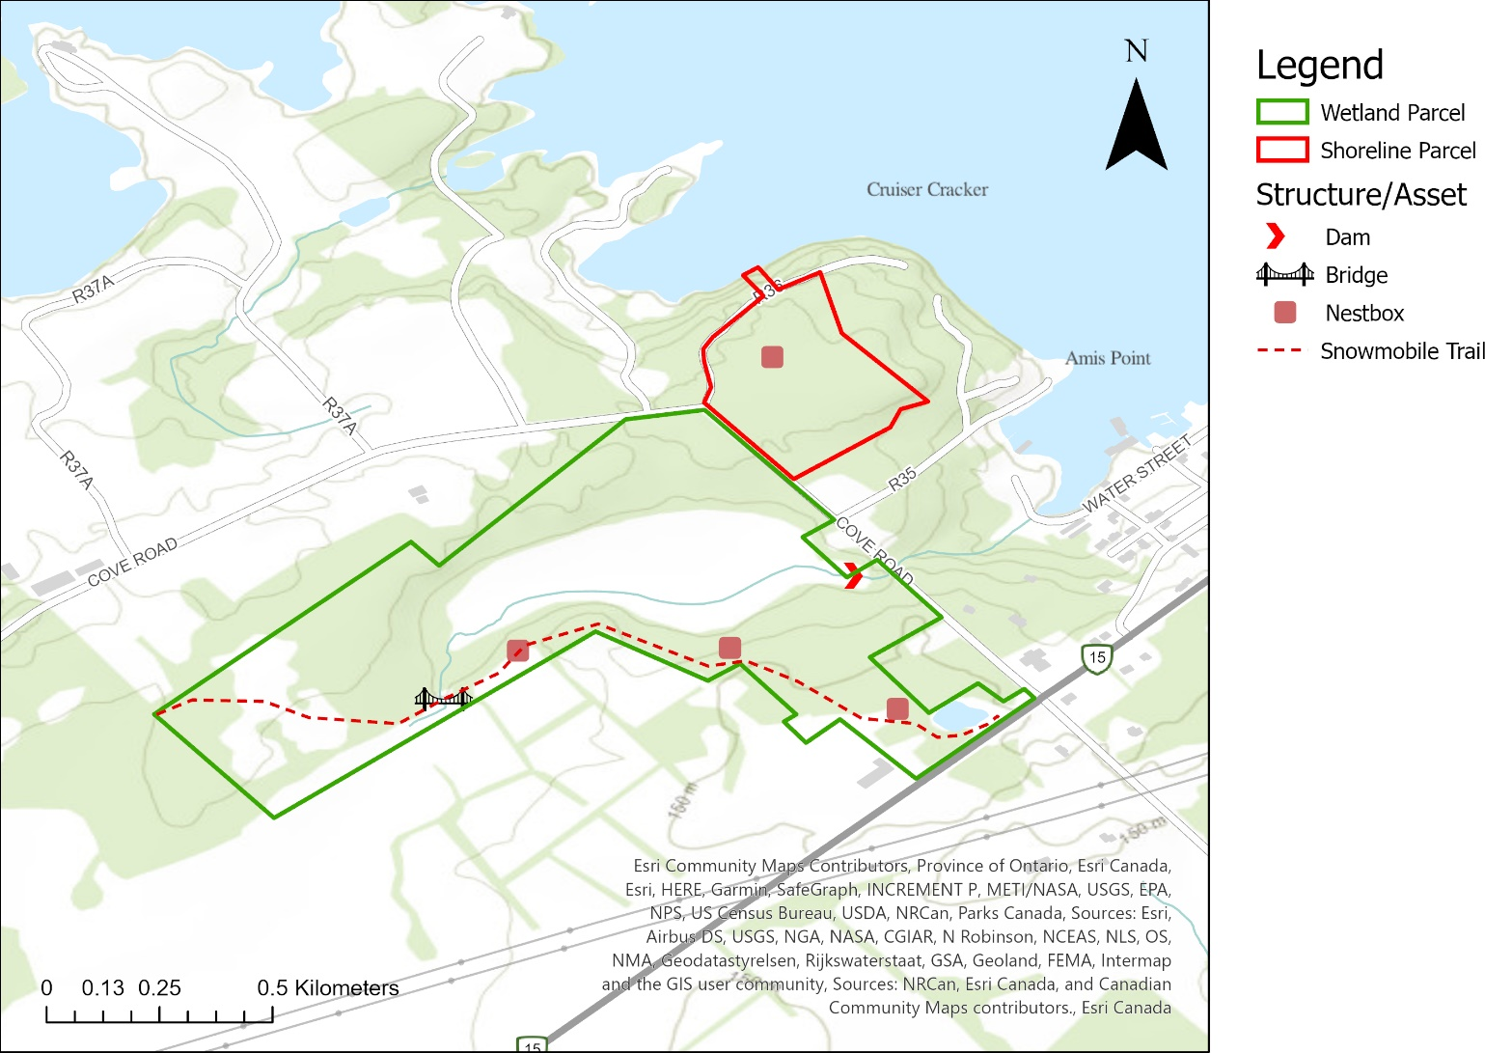
Figure 6: Improvements and Structures

Future Acquisitions
There are no current plans to acquire more property in the immediate vicinity of Edwards Wetland. However, the property is located within one of the RWLT’s priority areas, and future opportunities to acquire more land on undeveloped shorelines will be met favourably. Properties located up- or downstream of the wetland on the property (Figure 7) would be especially advantageous to acquire, as the hydrological linkages would allow species to more freely move between properties. As well, protecting more of the wetlands and streams would allow for improvements in water quality, riparian habitat, and the health of Big Rideau Lake

Stewardship
Edwards Wetland is visited at least once a year for a full property monitoring visit, typically by RWLT biology staff. Each year, the visit is done during a different season to account for the full variation in flora, fauna, and habitat. Monitors complete the monitoring template attached as Appendix B, documenting any changes in the property and/or any disturbances that may have occurred, as well as updating the species database. If there are any unwanted or illegal activities, RWLT staff and board members decide upon the necessary actions needed to resolve the issue. Additional updates on the property may be provided by the neighbors on the adjoining properties. Maintaining a relationship with the current and future owners of the adjacent parcels is an important component of stewardship and long-term conservation of all of the RWLT’s properties.

Baseline Inventory Summary
A formal Baseline Documentation Inventory for Edwards Wetland was completed in 2003 by Simon Lunn, retired biologist and (former) RWLT board member (Lunn, 2003). The information provided in this section summarizes that report and new information was incorporated where necessary.

Physical Features

Geology
The lands under consideration are situated within the Champlain (Land) District, an area characterized by flat-lying Paleozoic era bedrock. The bedrock is primarily 1 ½ billion-year-old Lower Ordovician sedimentary rock, including Oxford & March Formation limestones and dolomites. They belong to the Smiths Falls Limestone Plain Physiographic Region and constitute a topography of mostly well-drained gentle inland slopes that become steeper where they adjoin Big Rideau Lake. An arch-shaped largely west-facing rocky outcrop ridge or scarp is situated within the Shoreline Parcel, while a less pronounced linear outcrop or shallow south-facing scarp of loose limestone rock borders the wetland of the Wetland Parcel.
In contrast to the glacial till veneer overlying most of the lands, there is a pocket of Quaternary age post-glacially deposited organic muck underlying marsh habitat in the middle portion of the Wetland Parcel.

Soils
The primary soil (series) is generally well-drained sandy loam of the Farmington Series (Brown Forest Great Group), in the form of shallow or thin till (1-12” depth) overlying limestone bedrock, with some rocky outcrops.

Surface Hydrology
The property has a large marsh wetland with a slow-moving stream flowing through it (Figure 7). The entire property is part of the Big Rideau Lake – Portland Subwatershed. The stream enters the property from a wetland on the adjacent property to the west, goes under a small bridge, and then meanders through the deciduous forest before entering the marsh wetland. The stream flows through the wetland leaving a small amount of open water visible at times and exits to the east where a small DUC concrete dam controls the water level. This stream then goes through a culvert under Cove Road and eventually empties into Big Rideau Lake.
The topography of the property is fairly gentle on top of the ridge, with a moderate slope down to the wetland, draining any water into the marsh and leading to dry conditions elsewhere.
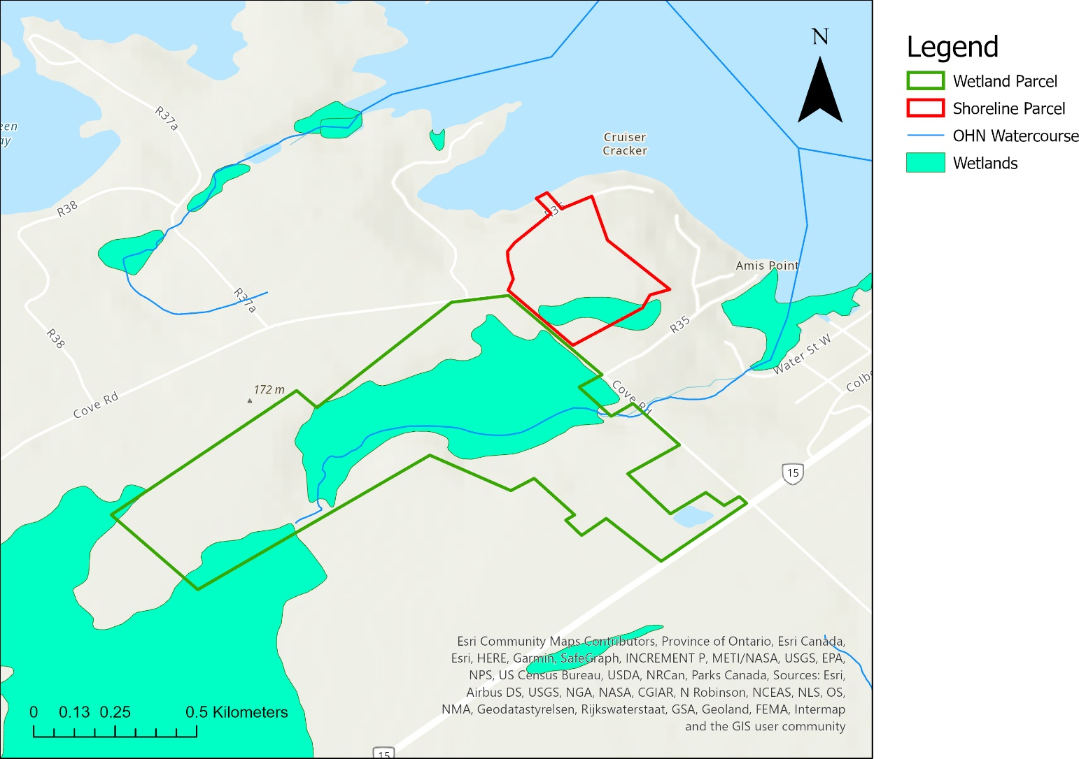
Figure 7: Surface Hydrology of Edwards Wetland and Surrounding Landscape

Climate
Edwards Wetland occurs in the Lake Simcoe-Rideau Ecoregion. The climate in this region is warmer and drier than that of 5E to the north and cooler with a lower evapotranspiration rate than 7E to the south. The area is generally cold and temperate with significant rainfall throughout the year.

Biological Features

Land Cover
Edwards Wetland is 57.45 hectares consisting mainly of forest and wetland, with some regenerating old field areas and an abandoned limestone quarry. The Wetland Parcel consists of approximately 50% forest, 35% wetland & stream, 14% regenerating old field and 1% flooded quarry. The Shoreline Parcel is 100% forest, mainly deciduous, with a small area of mixed forest in the southeast corner.

Flora
The vegetation communities of this property are typical of those in the area. Although no official ELC assessment has been completed, the baseline inventory does outline the major vegetation zones and their dominant species. The six vegetation communities on the larger (wetland) parcel and two vegetation communities on the smaller (shoreline) parcel are summarized below and show in Figure 7. A full description can be found in the Baseline Inventory (Lunn, 2003).
Table 3: Vegetation Communities Identified on Edwards Wetland
Parcel | Name | Description
Wetland | Maple Upland | Young to medium-age regenerating sugar maple
 | Ash Lowland | Lowland forest and transition zone next to wetland
 | Old Field | Fairly open regenerating old field
 | Marsh | Partially impounded wetland
 | Flooded Quarry | Abandoned limestone quarry
 | Mixed-wood Transition Zone | Transition zone along the stream outlet
Shoreline | Deciduous Woodland | Largely undisturbed, sugar maple dominated woodland
 | Mixed Forest | Scattered hemlocks
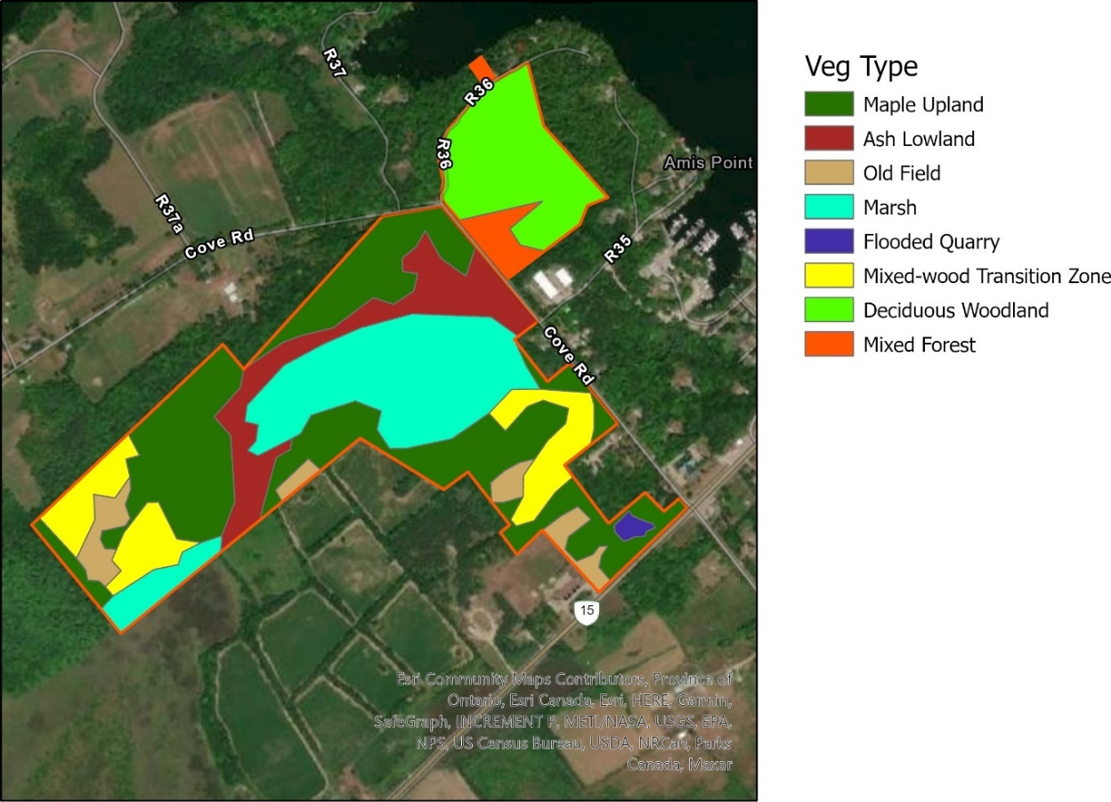
Figure 8: Vegetation Communities

Fauna
Edwards Wetland provides habitat for many species in the Portland, ON area (Table A-2). Thirty-five bird species have been seen on the property, including migratory songbirds, raptors, and waterfowl. Five species of frogs have been found on the property. Six mammal species have been found on the property, including beaver, fox, porcupine, and Southern flying squirrel. Two reptiles have been reported on or near the property. As well, there are various butterfly, moth and other insect species present on the property.

Species of Conservation Concern
Edwards Wetland provides suitable habitat for a wide range of flora and fauna, including nine species at risk. Some of these species were recorded many years ago, and targeted surveys should be undertaken to determine if the species is likely to still be present.
According to the Natural Heritage Information Centre, there are seven species of conservation concern known to be present in the area surrounding Edward’s Wetland. They include the American Eel and six species of reptile (Table 4). There is also a Mixed Wader Nesting Colony located nearby (Ontario Ministry of Natural Resources and Forestry, 2019).
Table 4 Species of Conservation Concern - NHIC
Common Name | Scientific Name | SARO Status | COSEWIC Status
American Eel | Anguilla rostrata | Endangered | Threatened
Blanding’s Turtle | Emydoidea blandingii | Threatened | Endangered
Eastern Milksnake | Lampropeltis triangulum | Not at Risk | Special Concern
Gray ratsnake | Pantherophis spiloides pop. 1 | Threatened | Threatened
Midland Painted Turtle | Chrysemys picta marginata |  | Special Concern
Northern Map Turtle | Graptemys geographica | Special Concern | Special Concern
Snapping Turtle | Chelydra serpentina | Special concern | Special Concern

Invasive Species
Initial surveys of the property indicate that the property has a high incidence of invasive species. Invasive species were recorded in almost every vegetation community on the property, often in large monocultures.
Table 5: Invasive Species Recorded on Edwards Wetland
Common Name | Date Observed | Description
Canada Thistle | August 6, 2020 | Observed by RWLT staff at the edge of the wetland
Common Buckthorn | August 6, 2020 | Abundant throughout the property
Dog Strangling Vine | June 9, 2021 | Abundant near beginning of snowmobile trail just off Highway 15, and continuing along trail into property
European frogbit | 2016 | Was observed by DUC while inspecting their concrete dam at the outflow from the wetland
Garlic mustard | August 6, 2020 | Observed by RWLT staff in the maple forest of both parcels
Purple loosestrife | August 6, 2020 | Abundant in the marsh wetland
White sweet clover | August 6, 2020 | Observed by RWLT staff near the old quarry
Tatarian honeysuckle | April 2003 | Abundant in the regenerating old field; reported in the Baseline Inventory
Yellow Archangel | March 19, 2021 | Locally abundant in Shoreline Parcel as a groundcover

Species at Risk Inventories
Targeted Species at Risk surveys for amphibians and nightjars took place on June 9, 2021. No SAR were heard at this time. Acoustic monitoring for SAR bat species was performed from June 7-9, 2021. We are still awaiting the results of this survey.

Conservation Context
Big Rideau Lake, which is adjoined by one of the two land parcels under consideration, is the largest lake within and part of the Rideau Canal, which is a Canadian National Historic Site, Canadian Heritage River and UNESCO World Heritage Site.
Under the current Rideau Canal Management Plan, “the waterway’s ecosystem features form an integral part of the history and natural landscape of the Rideau and are considered a vital heritage resource of the Canal system that must be respected and safeguarded” (Rideau Canal National Historic Site Management Plan, 2005, p. 14). The plan encourages working with partners, such as the RWLT, to identify ecologically sensitive lands and promote their protection as key co-operative actions as Parks Canada works to conserve and protect ecosystem resources surrounding the canal (Rideau Canal National Historic Site Management Plan, 2005, p. 57).
Parks Canada’s Rideau Canal Resource Conservation staff have indicated in the past that Parks Canada regards the conservation of natural landscapes, and in particular, wetlands, islands, and tracts of undisturbed forested shorelands along the canal to be worthy contributions to the maintenance of biodiversity within the Rideau Corridor and eastern Ontario (Lunn, 2003).
*Note: The draft Rideau Canal Management Plan released in 2021 no longer mentions the importance of protecting ecosystem features along the Rideau Waterway. It is unknown whether this will be addressed in the final version.

Protected Areas
Edwards Wetland is located about 4.5 km from another RWLT Conservation Land on Sherwood Point, which was also bequeathed by Ms. Edwards. Three other RWLT Conservation Lands are also located on Big Rideau Lake (Figure 8): Lady Kingsmill Nature Reserve on Grindstone Island (~ 3.5 km away), Red Rock on the western shore (~ 7 km), and MacDonald’s Island Wetland on the eastern shore of the lake (~3 km). The Edwards Wetland property is also located ~1 km from the Portland Conservation Area, owned by the RVCA. Parts of the provincially protected Big Rideau Lake – Bass Lake PSW are also located nearby.
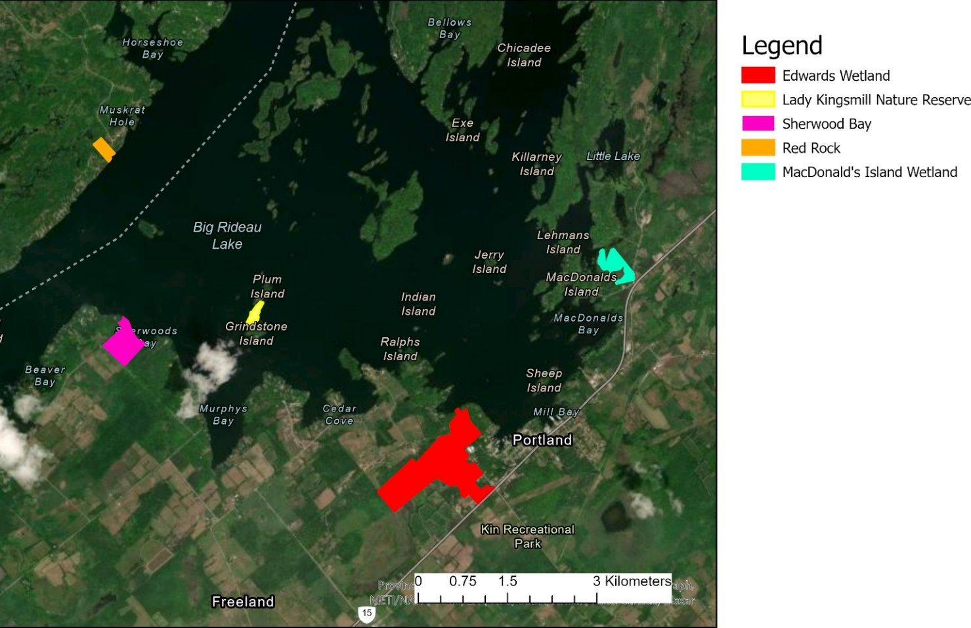
Figure 9: RWLT Conservation Lands on Big Rideau Lake

Policy Areas

Official Plan of the United Counties of Leeds and Grenville
The land is designated primarily as Rural Lands with a small portion near the corner of Highway 15 and Cove Road which is designated as Rural Settlement Area.
Appendix 2 identifies the land as part of the County's Natural Heritage System. Section 4.3(k) encourages the "creation of a linked Natural Heritage System through the integration" of various publicly owned lands and (ii)" areas in the ownership of land trusts."
Section 4.2.12, Crown Lands, Conservation Lands and Significant Local Features, contains general policies applicable throughout the United Counties, including a statement encouraging the activities of land trusts.

Official Plan of the Township of Rideau Lakes
This official plan was adopted by Council on October 20, 2003 and approved by the Ministry on April 2, 2004. The subject land is designated primarily as Rural with a portion at the intersection of Highway 15 and Cove Road designated as Village and Hamlet, part of the large designation covering all of Portland. The policies applicable to these designations are contained in sections 3.7 and 3.8. Neither section addresses private conservation uses.
Section 2 of the official plan contains General Development policies applicable to the entire Township. Section 2.12, Crown and Conservation Lands, acknowledges that some conservation lands are owned or managed by non-profit organizations. These are permitted anywhere in the Township.

Zoning By-law #2005-6
The Township of Rideau Lakes Zoning By-law zones the subject lands as Rural (RU), a category which allows a conservation uses which “shall mean the preservation, improvement and enhancement of natural resources or the natural environment.” This definition captures the existing and intended use of the Edwards Wetland property. When an opportunity arises in the future to provide input into a new comprehensive zoning by-law, it may be appropriate to place the land in a category which limits the permitted uses to just a conservation use.

Environmental Designations
Part of the Edwards Wetland property is designated as a Significant Groundwater Recharge Area, one of the four types of vulnerable areas identified in the Ontario Clean Water Act, 2006 (Rideau Valley Conservation Authority, 2019).

Landscape Context
Adjoining land is zoned rural, residential, institutional, environmental protection A, with nearby agricultural areas. The landscape matrix is mainly made up of agricultural and residential uses, with some larger patches of forest and wetland interspersed. There is high developmental pressure on the shores of Big Rideau Lake, of which the property has a small zone allowing for connection between shoreline and inland habitats.

Conservation Target Analysis
RWLT staff have worked collaboratively with the Ontario Land Trust Alliance to identify three main conservation targets for the Edwards Wetland property. Targets include forests, wetlands, and the provincially threatened Gray Ratsnake (Pantherophis spiloides). Each of these conservation targets is described below with a particular focus on their ecological significance. General assessment criteria are identified, and a rating assigned where possible.

Forests
There are several types of forest ecosystems on the Edwards Wetland property, including:
- Maple upland – Young and regenerating sugar maple
- Ash lowland – Lowland forest and transition zone next to wetland
- Mixed-wood transition zone – Mixed forest along stream outlet
- Mixed forest – Mainly deciduous with a few hemlocks, adjacent to Big Rideau Lake
- Mature deciduous forest – Largely undisturbed, sugar maple dominated

Ecosystem Description
Forest is the dominant ecosystem type on the two Edwards Wetland parcels, accounting for ~50% of the Wetland Parcel and 100% of the Shoreline Parcel. Most of the forest is deciduous, where sugar maple is the dominant species over much of the area. A few areas of mixed forest appear near the wetland and stream on the Wetland Parcel, and on the small strip of the Shoreline Parcel adjoining Big Rideau Lake.

Biodiversity
Except for seasonal use by snowmobilers, the entire Edwards Wetland property has been managed as a nature preserve since acquisition, and with minimal human intrusion under the stewardship of the previous landowner. The Wetland Parcel contains mainly young to middle-aged forest, with regenerating sugar maple, basswood, birch, oak, hop-hornbeam, and a wide variety of other hardwoods. Scattered hemlocks and eastern white cedar are found dispersed across the property in several transitional zones situated in the wetter areas. The Shoreline Parcel is heavily dominated by mature sugar maples, with a few large red oak, young hop-hornbeam, and other scattered hardwood species. The understorey is primarily young regenerating sugar maple saplings. A more detailed description of these ecosystems can be found in the Baseline Inventory (Lunn, 2003).
These forests create a varied habitat that supports a wide variety of native forbs and ferns, including blue cohosh, white trilliums, and maidenhair ferns. Understorey plants provide an important food source for white-tailed deer and other forest wildlife. There is abundant evidence of deer using the forest over the winter and at other times of the year.
Thirty-five species of birds have been recorded on the Edwards Wetland property, including several area-sensitive forest bird species. Species that nest in interior habitat including the black-and-white warbler (Mniotilta varia), ovenbird (Seiurus aurocapillus), hairy woodpecker (Picoides villosus), and pileated woodpecker (Dryocopus pileatus) (Rideau Valley Conservation Authority, 2000) have all been seen on the property in the breeding season of 2021. Five other species that prefer interior forest or large woodland areas have also been identified during 2021 surveys, including the rose-breasted grosbeak (Pheucticus ludovicianus) (University of Florida), American redstart (Setophaga ruticilla), red-eyed vireo (Vireo olivaceus), red-shouldered hawk (Buteo lineatus), and wood thrush (Hylocichla mustelina) (Jones, McCann, & McConville, 2000).
Five species of frogs have been seen in the forests on the Edwards Wetland property. The wet conditions present in areas of the forest may provide the ideal conditions for amphibians, including the formation of vernal pools, although targeted surveys during May 2021 did not provide any evidence of amphibian breeding in the pools. This may have been due to the delayed timing of the monitoring visit due to COVID.

Assessment
Table 6: Target Viability Assessment for Forests
Type | Key Attribute | Indicator | Ranking | Notes
Size/Extent | Size of Characteristic Communities | Area of forest | Good | There are approximately 40.6 hectares of forest on the property, and parts of it are continuous with forest cover on adjacent properties
 | Size of Characteristic Communities | Area of interior forest | Fair | There are approximately 4.5 hectares of interior forest with a 100m buffer
Condition | Community health | Number of forest layers | Very Good | Forest communities on the property vary in age of succession, ranging from mid-successional areas to mature maple-dominated stands
 | Community health | Percent of trees with disease or damage | Fair | In some areas, there are trees completely covered with what appears to be galls. There is also significant damage from gypsy moths.
 | Community composition | Percent native plant species | Good | The majority of plant species are native, although there are at least 9 invasive species and several others that are nonnative
 | Indicator Species | Number of interior forest birds | Good | Large, intact forests reduce nest predation and parasitism that many forest-dwelling bird species are subjected to. The presence of forest interior birds, specifically those that are edge-intolerant, is an indicator of quality interior forest habitat. During 2021 breeding bird surveys, there were nine species identified that are associated with large forests and interior habitat (Jones, McCann, & McConville, 2000; Rideau Valley Conservation Authority, 2000; University of Florida)
 | Indicator Species | Amphibian diversity | Fair | There are several amphibian species present on the property. However, there was no visible evidence of breeding in vernal pools, and very few calling frogs during 2021 monitoring visits
Landscape Context | Connectivity with Adjacent Natural Areas | Percent natural area within surrounding 5 km | Fair | The majority of the surrounding landscape is non-natural. However, the area is mainly rural, with low amounts of impervious built-up areas. Agricultural fields will still allow most movement of animals
Overall Ranking |  |  | Fair

Cattail Wetland

Ecosystem Description
A large cattail-dominated marsh makes up approximately 35% of the Wetland Parcel and includes a small stream that emerges from the neighbouring property to the southwest, flows through the marsh, and exits the property at the northeast corner at a Ducks Unlimited Canada control structure, eventually flowing into Big Rideau Lake. The entire property falls within the Big Rideau Lake – Portland catchment area.

Biodiversity
The partially impounded wetland is primarily a dense, flooded cattail-dominated emergent marsh surrounded by a band of Red-Osier Dogwood and featuring a patch or two of willow and other shrubs.
A number of waterfowl have been identified on the property and may make some use of the wetland, including red-winged blackbird (Agelaius phoeniceus), wood duck (Aix sponsa), Canada Goose (Branta canadensis), great blue heron (Ardea herodias), green heron (Butorides virescens), mallard (Anas platyrhynchos), osprey (Pandion haliaetus), and snipe (Gallinago delicata).
Targeted amphibian surveys provided evidence of calling green frogs at the outlet of the wetland. No other use of the wetland by reptiles or amphibians has been recorded but is expected to occur.

Assessment
Table 7: Target Viability Assessment for Cattail Wetland
Type | Key Attribute | Indicator | Ranking | Notes
Size/Extent | Size of characteristic communities | Size of wetland compared to the historic extent | Very Good | Size and shape of wetland are almost identical to 2005 imagery (Google Earth)
Condition | Species composition | Percent native plant species | Good | The majority of the wetland species are native, although there is a large number of purple loosestrife plants
 | Indicator species | Presence of wetland-specific species | Fair | At least 8 bird species associated with water features have been identified on the property, as well as beavers, frogs, etc. However, most of these observations are from >5 years ago
Landscape Context | Connectivity with adjacent natural areas | Proximity to other wetlands/water bodies | Very Good | The marsh on the property is hydrologically connected to a large wetland on the neighbouring property to the west and Big Rideau Lake to the east
Overall Ranking |  |  | Good

Gray Ratsnake

Description
In Canada, the Gray Ratsnake is found only in Ontario, where there are two distinct populations. The Carolinian region has several small, disjunct subpopulations, and the population overall is considered Endangered. In the Frontenac Axis, there is a single subpopulation that extends into upper New York State but is disconnected from the populations present in the rest of the United States. The Frontenac Axis population of Gray Ratsnakes is considered Threatened under both the Ontario and the Federal Species at Risk Acts.
The Gray Ratsnake is Ontario’s largest snake, reaching up to 2 m in length. Some adults will try to protect themselves by coiling their bodies and vibrating their tails in dead leaves to simulate a rattle, leading to the occasional misidentification as a rattlesnake. Due to their large size and misidentification, ratsnakes are sometimes persecuted by people frightened of them, although the species is very docile and will not harm people. Other threats include habitat degradation and fragmentation, habitat loss, disturbance or destruction of hibernacula, and road mortality.

Edwards Wetland
Gray ratsnakes are typically associated with deciduous forests and prefer a matrix of forest and open areas for hunting and thermoregulation. The regenerating old field areas of the Edwards Wetland property would appear to be ideal habitat for them, especially with the numerous cracks and fissures in the rock that could act as hibernacula sites.
In the fall of 2020, four nestboxes were installed on the property to augment natural oviposition sites and protect any nests from predation. The life history of Gray Ratsnakes (late age of maturity, long life span, biennial reproduction, and intermittent juvenile recruitment) predisposes the species to major fluctuations in population size in the face of disturbances such as deliberate killing or incidental road mortality. It is hoped that increasing the number of eggs that successfully hatch will allow for a recovery in population numbers.

Assessment
Table 8: Target Viability Assessment for Gray Ratsnake
Type | Key Attribute | Indicator | Ranking | Notes
Size | Recruitment | Number of nests per year | NA | Nestboxes are newly installed in the fall of 2020, and no data will be available until after the nesting season of 2021
 | Recruitment | % of eggs that successfully hatched | NA
 | Recruitment | Total number of eggs laid | NA
Overall Ranking |  |  | Unknown

Other Targets
Also located on the property is an abandoned limestone quarry. Although it has naturalized over the years, further surveying should be done to see if there are any interventions that could improve the habitat quality provided by the flooded quarry. Safety considerations also need to be discussed to prevent injury from people accidentally or purposefully entering the pool of water in the quarry or falling from the top of the cliff face.

Threats

Invasive Non-Native/Alien Plants and Animals
At least 9 invasive species are present on the Edwards Wetland property, affecting all ecosystems. The most harmful invasive plants on the property include purple loosestrife which was widespread in the wetland, garlic mustard in the mature forest, and buckthorn which grows in the forest and the regenerating old field habitats. Invasive species are likely to have a detrimental effect on the Forest and Wetland targets, with little to no effect on the health of the Gray Ratsnake.

Hunting and Collecting Terrestrial Animals
During the winter of 2020-21, neighbours found evidence of hunting in the southwest corner of the forest. This included a ground hunting blind, a pile of deer bait, and a portable hunting blind mounted to a hemlock tree. A note was left on the bait pile by the neighbour, and the ground blind was subsequently removed. The tree blind is still present as of the writing of this plan but is scheduled to be removed during the upcoming field season.

Utility and Service Lines
There is a small hydro corridor on the northwest corner of the Wetland Parcel, parallel to Cove Road. Vegetation along this corridor is managed by the hydro company. The area affected by this corridor is very small, spanning about 160m in length, and impacts only the Forest conservation target. Management of vegetation along R36 is also managed by the hydro company and was last completed in summer 2021.

Motorized Vehicles and Associated Infrastructure
On the Wetland Parcel, there is a section of an old forestry roadway that is used as a snowmobile trail by the local club. The maintenance of this trail does have some effect on the Forest target, although damage is diminished by restricting use to only the winter when plants and most animals are dormant. This trail does attract some unauthorized ATV use that would have a greater impact on the Forest target and could lead to mortality or disturbance of the Gray Ratsnakes as well.
The property is also bordered by roads on 2 sides of each parcel – Highway 15 and Cove Road for the Wetland Parcel, and Cove Road and R36 for the Shoreline Parcel. This poses a threat to all of the conservation targets. Salt, debris, and other unwanted contaminants can easily wash from the roads into the forest and wetland, although the wetland is upstream of the stream flowing under the road so contamination would be minimized. Additionally, Gray Ratsnakes travelling between parcels, or between Edwards Wetland and the adjoining landscape, risk being hit by vehicles travelling on any of these three roadways, one of which (Highway 15) is a major transportation route.

Garbage and Solid Waste
RWLT staff documented widespread small garbage at the beginning of the snowmobile trail, including beer cans, food wrappers, and various other debris. This could have possibly come from the road, although the property fence would block most of it. There are also old pieces of metal located in the forest from historical uses of the property. Most of these do not pose much immediate danger, although some old wire fencing may be a hazard.

Climate Change
According to the Climate Change Vulnerability assessment completed for this property, climate change is likely to compound the effects of existing threats as well as put new stresses on the conservation targets.
Threats related to invasive species, pests, and diseases, in particular, may become more pronounced in conjunction with climate change. Extreme weather events, which are expected to increase in frequency in the future, can cause disturbance to the forest and create new opportunities for invasive species to colonize. Increased temperatures could lead to heat stress in some species, making them more susceptible to disease or pests, and more likely to be outcompeted by non-native species, especially those better adapted to higher temperatures.
Climate change may also create new threats that do not currently impact the conservation targets. It is expected that overall, there will be an increase in temperatures and precipitation, especially in the fall, winter, and spring months. The consequence of an increase in winter temperatures is that more precipitation will accumulate as rain instead of snow. This could potentially flood hibernacula that the Gray Ratsnakes depend on, leading to mortality and loss of important winter habitat. Increased rainfall during these months may also lead to increased runoff from the agricultural fields immediately surrounding the property, potentially resulting in significant nutrient loading which could reduce the diversity of plants present on the property. Nutrient loading favours a small number of plants, many of them exotic, which may outcompete native plants and reduce biodiversity. Temperature increases, especially in the summer, coupled with similar amounts of rainfall, may also lead to more frequent droughts. This could lead to temporary reductions in the size of the wetland and possibly disconnection from adjacent water bodies if the connecting stream dries up. Vernal pools may also dry up sooner in the face of increased temperatures, reducing the likelihood that amphibian species successfully reproduce.
General anticipated changes resulting from climate change also include species migration and changes in species ranges. The changes in temperature and precipitation patterns will affect the species that can thrive on the property under future climate scenarios. It is an important consideration for any restoration work that may take place on the property to ensure that activities are sustainable under current and future climate projections.

Management Goal, Objectives and Actions

Management Goal
RWLT intends to maintain the ecological integrity of Edwards Wetland. This nature reserve has extensive forest and wetlands and supports many species at risk. It is our goal to ensure its persistence as well as the species it supports into the future. This is especially important considering that fact that the surrounding landscape is increasingly developed, leaving Edwards Wetland to serve as a refuge to the forest flora and fauna.

Stewardship Actions
The following was compiled based on the Conservation Actions Classification (V2.0) created by the Conservation Management Practices (IUCN, 2012).
Table 9: Planned Stewardship Actions
Action Category | Description | Target(s) | Threat(s) |  | Frequency
Land/Water Management | Monitor property boundaries for evidence of trespass, threats, risks and liabilities | All | All | - Annual monitoring visits to check the property. This includes monitoring the property boundary, changes to the land, evidence of trespass, threats, SAR, and invasive species.  - A monitoring form is completed, and data is stored in a database. Any issues and threats are addressed. | Annually
Land/Water Management | Monitor property for undocumented anthropogenic features | All | All | - Annual monitoring visits to check the property for features including trails, cabins, hunting blinds.  - A monitoring form is completed and data is stored in a database. Features are known and removed/addressed. | Annually
Land/Water Management | Determine feasibility of public access for hiking | All | All | - Determine if public access for low-impact recreation will negatively impact conservation values  - Determine what, if anything, needs to be done to reduce the hazard presented by the flooded quarry | 2021-2022
Land/Water Management | Monitor property for invasive species | All | Invasive species | - Inventory property to document location and extent of invasive species on the property and develop an action plan.  - Action plan will mitigate impacts of invasive species. Scope and severity of threat are better understood. | Annually
Species | Maintain current species list for the property | All | All | Annual monitoring visits to document incidental SAR, birds, reptiles, and amphibians.  Species list is updated. Database is updated with new observations. SAR/tracked species are reported to NHIC. | Annually
Species | Breeding Bird Surveys | Forest | All | Undertake approved breeding bird survey and/or targeted SAR bird survey.  Sites established for personnel to undertake BBS and Nightjar surveys. Database updated with new records. SAR/tracked species reported to NHIC. Data will help inform management plans, stewardship actions, priorities. | 2021, Every 2 years
Species | Gray Ratsnake | Gray Ratsnake |  | - Complete survey protocol for nestboxes as well as for snakes on the property.  - Database is updated with new observations. SAR/tracked species are reported to appropriate body. | Annually
Species | Gray Ratsnake | Gray Ratsnake |  | - Develop SAR Action Plan to assess needs and threats and identify recovery actions  - Implement priority actions | 2021
Species | Amphibian Surveys | Forest, Wetland | All | Undertake approved amphibian survey and targeted Western Chorus Frog Survey.  Sites established for amphibian monitoring. Database updated with new records. SAR/tracked species reported to NHIC. Data will help inform management plans, stewardship actions, priorities. | 2021, Every 2 years
Awareness Raising | Install identification sign  Maintain signage on the property boundaries | All | All | Annual monitoring to check that signs are in good condition and reflect permitted uses on the property.  Signs installed/maintained. Trespassing minimized. | Annually
Law & Policy | Connect with Indigenous communities | All | All | Meet with local Indigenous communities to discuss the property and community interests.  Relationship established and traditional knowledge incorporated into property stewardship | Ongoing
Research & Monitoring | Identify vegetation communities | All | All | Identify and map all ELC communities on the property.  ELC data updated to inform stewardship | 2021, Every 5 years
Research & monitoring | Address climate change threats | All | Climate Change | Assess vegetation type and size of buffers around wetlands/watercourses on the property.  Understand buffer contributions to water filtration and shade. Inform stewardship to increase buffers and shade. | 2022, Every 2 years
Research & Monitoring | Monitor vernal pools | Forest | Climate Change | Undertake vernal pool monitoring protocol in forest habitat (amphibian diversity/abundance, hydrological characteristics)  Improve understanding of impacts of climate change on VP and amphibians. | 2021, Every 2 years
Education and Training | Train staff | All | All | Provide personnel with specific knowledge and skills in species ID and survey protocols  Personnel is trained and better able to undertake actions. | Ongoing
Institutional Development | Secure funding for permanent and seasonal staff | All | All | Identify funding sources and positions  Funding secured, increase capacity | Ongoing
Institutional Development | Establish volunteer community | All | All | Volunteers are trained to undertake annual monitoring and where relevant additional targeted surveys.  RWLT grows current volunteer pool and increases engagement with those volunteers. | Ongoing
Institutional Development | Establish partnerships | All | All | Establish formal agreement with snowmobile club regarding trail maintenance | 2021
Institutional  Development | Establish alliances/partnerships | All | All | Partnerships are formed with organizations with shared priorities (DUC, RVCA)  Coordinated conservation – data is shared. | Ongoing
Institutional Development | Secure financial support for conservation activities | All | All | Funding sources identified and applied for where appropriate  Secured funds support stewardship actions | Ongoing

Stewardship Cost Summary
Table 10: Cost breakdown to implement management actions
For full stewardship budget breakdown, see Appendix D: Stewardship Budget. All prices are based on 2021 unit costs.
Action | Cost | Frequency
Property taxes and insurance  - Register property under CLTIP CCL  - Maintain insurance policy  - Pay property taxes if the entire property is not eligible under CLTIP | Insurance Cost: $967.63  Property Taxes: $100  Staff Time: $108  Total = $1175.63 | Annually
Signage Replacement  - Identification Sign  - No Trespassing Signage  *Estimated lifespan of signs = 10 years | Cost of Signage: $400  Labourer Time: $90  Travel: with other trip  Total = $490 | 2031, Every 10 years
Annual Monitoring:  - Conduct annual monitoring visit and complete form  - Where appropriate, this visit can also include the following:  - Invasive species inventory  - Ratsnake nest box  - Snake boards?  - Record incidental SAR  - Record all species encountered  - Trail monitoring  - Update database with new information | Biologist Time: $378  Assistant Time: $210  Travel: $70  Total = $658 | Annually
Bi-Annual Monitoring (in addition to annual monitoring)  - Breeding Bird Surveys  - Amphibian Surveys | Biologist Time: $378  Assistant Time: $210  Travel: $70  Total = $658 | Every 2 years
Planning and Database Update  - Plan monitoring visits  - Write reports  - Report SAR to NHIC  - Update species database | Biologist Time: $756  Total = $756 | Annually
Yearly maintenance  May include the following as needed:  - Removal of invasive species  - Removal of hunting blinds/other unauthorized construction | Biologist Time: $378  Labourer Time: $210  Travel: $70  Total: $658 | Annually, as needed
Partner Liason  - Establish partnership with snowmobile club  - Maintain partnerships with DUC, RVCA | Staff Time: $216  Total = $216 | Annually
Plan Update  - 2 site visits in addition to annual monitoring (to see property in 3 seasons)  - Estimated 5 days of revising PMP and getting approved | Biologist Time: $2646  Assistant Time: $420  Travel: $140  Total = $3206 | 2026, Every 5 years
Ratsnake Nestboxes  - Check for eggshells  - Replenish nesting materials  - Maintain box frame as needed | Biologist Time: $216  Labourer Time: $120  Travel: $70  Materials: $132  (covered by ECCC grant to EcoTec for first 5 years)  Total = $406 ($538 after 2026) | Annually; Optional

Management Plan Review
Every 5 years – starting June 2026.

References
Environment and Climate Change Canada. (2021). The Canadian Ecological Gifts Program Handbook. Gatineau, Quebec. Retrieved from http://publications.gc.ca/collections/collection_2021/eccc/cw66/CW66-157-2021-eng.pdf
IUCN. (2012). CMP Unified Classification of Conservation Actions Needed. Retrieved from IUCN Red List: https://www.iucnredlist.org/resources/conservation-actions-classification-scheme
Jones, C., McCann, J., & McConville, S. (2000, June). A Guide to the Conservation of Forest Interior Dwelling Birds in the Chesapeake Bay Critical Area. Retrieved from Maryland Department of Natural Resources: https://dnr.maryland.gov/criticalarea/Documents/forms_navbar/tweetyjune_2000.pdf
Lunn, S. (2003). BASELINE INVENTORY & ENVIRONMENTAL AUDIT (interim). Kingston, Ontario.
Nasmith, R. (2021).
Ontario Ministry of Natural Resources. (2021). Conservation Land Tax Incentive Program. Retrieved from Ontario.ca: https://www.ontario.ca/page/conservation-land-tax-incentive-program
Rideau Canal National Historic Site Management Plan. (2005). Retrieved from Parks Canada: https://www.pc.gc.ca/en/agence-agency/bib-lib/plans/~/media/D1E5E8065FB54B86BBF3858E342E7091.ashx
Rideau Valley Conservation Authority. (2000). Conserving the Forest Interior: A Threatened Wildlife Habitat. Retrieved from LandOwner Resource Centre: http://www.lrconline.com/Extension_Notes_English/pdf/forInterior.pdf
Rideau Valley Conservation Authority. (2019). Significant Groundwater Recharge. Retrieved from RVCA GIS Open Data: https://rvcagis.github.io/jkan/datasets/significant-groundwater-recharge/
RWLT Board of Directors. (2008). RWLT Land Selection Criteria.
Spang, C., & Fiedler, A. (2021). Land Acquisition Guide.
University of Florida. (n.d.). Appendix A. COMBINED AVIAN SPECIES LIST FROM ALL THREE SYSTEMATIC REVIEWS. Retrieved from Building for Birds: https://wec.ifas.ufl.edu/buildingforbirds/web/birdlists/masterlist.pdf

Appendices

Appendix B: Monitoring Report Template
Property Monitoring Report Form
Please complete this form and include any supporting illustrations, maps or photos in the appropriate section. Please email the completed form to lands@rwlt.org or give directly to RWLT Ecologist.

Community Land or Conservation Land
(circle one)
Property: |  |  |  |  |  |  |  |  |  | Date of Visit:
Name(s) of Monitor(s): |  |  |  |  |  |  |  |  |  | Contact Information:
Report Completed By:
Date of Last Monitoring Visit:
Management Plan Reviewed: |  |  |  |  |  |  | ☐ Yes |  |  | ☐ No
Follow-up Required? |  |  |  |  |  |  | ☐ Yes |  |  | ☐ No
If yes, please describe:

Management Action Taken: |  |  |  |  |  |  | ☐ Yes |  |  | ☐ No
If yes, please describe:
I - Hazards
Bears |  |  |  | ☐ |  |  |  | Tree Snags |  |  |  | ☐ |  |  | Old Wells |  |  |  | ☐
Poison Ivy |  |  |  | ☐ |  |  |  | Other |  |  |  | ☐
Describe:

II - Existing Structures (buildings, signs, footbridges, fences, etc.)
Structure |  | Location |  |  |  |  |  |  | Condition |  |  |  |  | Comments
III - Recreational Uses (Please check off those activities observed and whether they are either allowed (A) or prohibited (P)).
 |  |  | A |  |  | P |  |  |  |  | A |  | P |  |  |  |  | A |  | P
Formal Trails |  |  | ☐ |  |  | ☐ |  | Picnicking |  |  | ☐ |  | ☐ |  |  | Skating |  | ☐ |  | ☐
Informal Trails |  |  | ☐ |  |  | ☐ |  | Swimming |  |  | ☐ |  | ☐ |  |  | Snowmobiling |  | ☐ |  | ☐
Hiking |  |  | ☐ |  |  | ☐ |  | Camping |  |  | ☐ |  | ☐ |  |  | Snowshoeing |  | ☐ |  | ☐
Berry Picking |  |  | ☐ |  |  | ☐ |  | Boating |  |  | ☐ |  | ☐ |  |  | Trapping |  | ☐ |  | ☐
Nature Appreciation |  |  | ☐ |  |  | ☐ |  | Cycling |  |  | ☐ |  | ☐ |  |  | Dog walking |  | ☐ |  | ☐
Bird Watching |  |  | ☐ |  |  | ☐ |  | Rock Climbing |  |  | ☐ |  | ☐ |  |  | Equestrian use |  | ☐ |  | ☐
Photography |  |  | ☐ |  |  | ☐ |  | X-country Skiing |  |  | ☐ |  | ☐ |  |  | Angling |  | ☐ |  | ☐
Hunting |  |  | ☐ |  |  | ☐ |  | Bus tours |  |  | ☐ |  | ☐ |  |  | Motorized vehicles |  | ☐ |  | ☐
Other |  |  | ☐ |  |  | ☐
Describe:

IV - Natural Heritage Values
- Wildlife Observations (mammals, amphibians, reptiles, fish, birds, other):
- Vegetation (trees, shrubs, plants):
- Habitat Features (examples: snags/cavity trees, fallen trees, confer thickets, brush piles, waterfowl nesting, waterfowl feeding, dens, nests, wildlife trails, etc.):
V - Disturbances
- Natural
Beaver Dams |  |  |  | ☐ |  |  |  | Erosion |  |  |  | ☐ |  |  | Fire |  |  |  | ☐
Flooding |  |  |  | ☐ |  |  |  | Heavy deer browsing |  |  |  | ☐ |  |  | Siltation |  |  |  | ☐
Wind falls |  |  |  | ☐ |  |  |  | Invasive species |  |  |  | ☐ |  |  | Other |  |  |  | ☐
Describe:

- Human
Camping |  |  |  | ☐ |  |  |  | Pesticides |  |  |  | ☐ |  |  | Road widening |  |  |  | ☐
Channelization of Streams |  |  |  | ☐ |  |  |  | Horseback riding |  |  |  | ☐ |  |  | Shoreline alteration |  |  |  | ☐
Clearing of municipal drains |  |  |  | ☐ |  |  |  | Motorized vehicles |  |  |  | ☐ |  |  | Stray animals |  |  |  | ☐
Ditching |  |  |  | ☐ |  |  |  | Mountain bikes |  |  |  | ☐ |  |  | Trampling |  |  |  | ☐
Dumping |  |  |  | ☐ |  |  |  | Pets |  |  |  | ☐ |  |  | Trapping |  |  |  | ☐
Feeding wildlife |  |  |  | ☐ |  |  |  | Plant harvesting |  |  |  | ☐ |  |  | Trespass |  |  |  | ☐
Fires |  |  |  | ☐ |  |  |  | Poaching |  |  |  | ☐ |  |  | Unauthorized construction |  |  |  | ☐
Urban runoff |  |  |  | ☐ |  |  |  | Utility corridors |  |  |  | ☐ |  |  | Vandalism |  |  |  | ☐
Other |  |  |  | ☐
Describe:

VI - Contact with Neighbours or Visitors (briefly describe your conversation, provides names if possible):

VII - Notes/Comments:

VIII – Maps, Illustrations, Photographs

Appendix E: Restrictions Upon Use or Disposition Of Edwards Wetland

CLTIP
The Conservation Land Tax Incentive Program offers a 100% rebate on property taxes on eligible properties in exchange for a long-term commitment to steward them as conservation lands. Only uses deemed compatible with the natural heritage and biodiversity objectives are allowed on properties enrolled in CLTIP. This includes but is not limited to:
- low-impact recreational activities such as hiking, skiing, hunting, fishing, and wildlife viewing,
- routine land-use activities such as invasive species management, prescribed burns, trail maintenance, tree removal for safety or forest health purposes, and planting of native species.
Other land-use activities may be permitted if approval from MNRF program staff is solicited, including:
- culling nonnative tree species
- sustainable fuelwood removal for personal use only
- planned trail development or upgrading.
Land uses such as:
- building structures
- landscaping or grooming areas
- farming areas
- use of motorized vehicles (off-trail)
- sale of forest products (timber and non-timber products)
- alteration of ecosystems by draining, dredging, filling, grading or extracting aggregate
are incompatible with objectives under CLTIP and will likely result in the portions of the property affected becoming ineligible for tax exemption and may result in past taxes being charged if the change was made in previous years.

Conservation Easement Agreement (CEA)
The CEA donated by Ms. Edwards in 2003 and registered on title places the following restrictions upon the use of Edwards Wetland.
The Owner shall not:
- Grant easements in, over, on, under or through the property
- Sever or subdivide the lands
- Construct any new buildings
- Use or allow the use of pesticides, chemicals, or other toxic materials
- Change the general appearance or topography of the lands, including installing drainage ditches or dams, dredging, or removing soil, gravel, sand, or other materials
- Remove vegetation except to maintain the existing trails or to prevent injury or to protect native vegetation on the property
- Allow commercial hunting, fishing, or trapping
- Use or allow the use of firearms on the land
- Undertake any activities detrimental to water conservation, erosion control, soil conservation or the preservation of native species
However, the easement states that activities can be undertaken with written authorization from the Rideau Waterway Land Trust. As the RWLT now holds fee simple title to the property, activities deemed necessary for the conservation of the property but not allowed under the CEA would be considered to have received ‘written authorization’ if the Board of Directors has approved them.

EcoGift
The 2003 CEA donated by Ms. Edwards to the RWLT was registered as an EcoGift. This provided Ms. Edwards with significant tax benefits and ensured that the RWLT would conserve the property’s biodiversity and environmental heritage in perpetuity.
Written authorization from Environment and Climate Change Canada is required for any changes in use or dispositions of properties certified as an EcoGift. Failure to receive this authorization before making changes to the property may result in a penalty tax equal to 50% of the current fair market value of the property.
Changes of use that would enhance or restore the conservation value of the property are typically authorized. Any change in use that is not consistent with the original objectives of the ecological gift, such as subdivision, the building of structures or trails, or other changes that may threaten the environmental values, are not likely to be allowed. As well, the sale or transfer of ownership can only be to another conservation organization that is authorized by ECCC as an EcoGift recipient.

