Property Management Plan

for

Lady Kingsmill Nature Reserve

Date of Report: | September 10, 2021
Prepared for: | Rideau Waterway Land Trust
Author/s: | Alyssa Fiedler and Caroline Spang  RWLT Conservation Biologists
Reviewer: | Morgan Roblin,  OLTA Conservation Science Manager
Version: | Final – Approved September 10, 2021

Acknowledgements and Disclaimers

This Property Management Plan was prepared by Alyssa Fiedler, Conservation Biologist, Rideau Waterway Land Trust with guidance from Morgan Roblin, Conservation Science Manager, OLTA.

Cover illustration provided by Alyssa Fiedler, RWLT Conservation Biologist.

For further information, please contact:
Rideau Waterway Land Trust
info@rwlt.org
613-305-3507
www.rwlt.org

Contents

1 Mission Statement 5
1.1 Vision, Mission, and Guiding Principles 5
1.2 General Guidelines for Management Plan 5
1.3 Site Information used for this Management Plan 5
2 Property Management Plan Summary 6
2.1 Property Information 6
2.2 Biodiversity Values 8
2.3 Conservation Targets and Threats 9
2.4 Conservation Management Goal and Objectives 10
2.5 Five-year Budget Summary 10
3 Background 11
3.1 Purpose of the Management Plan 11
3.2 Rideau Waterway Land Trust’s Conservation Efforts 11
3.3 Lady Kingsmill Nature Reserve Vision and Goals 12
3.4 Property Description 13
4 Property Management 14
4.1 Historical Land Use 14
4.2 Acquisition History 15
4.3 Current Management 15
4.4 Future Acquisitions 15
4.5 Stewardship 15
5 Baseline Inventory Summary 16
5.1 Physical Features 16
5.2 Biological Features 17
5.3 Conservation Context 18
5.4 Landscape Context 20
6 Conservation Target Analysis (Conservation Targets, KEA, Indicators) 20
6.1 Forests 21
6.2 Shoreline and Adjacent Wetlands 22
7 Threats 24
7.1 Human Intrusions & Disturbances 24
7.2 Garbage and Solid Waste 25
7.3 Invasive Non-Native/Alien Plants and Animals 25
7.4 Climate Change 25
8 Management Goal, Objectives and Actions 26
8.1 Management Goal 26
8.2 Stewardship Actions 27
8.3 Stewardship Cost Summary 29
9 Management Plan Review 30
10 References 31
11 Appendices 32
11.1 Appendix B: Monitoring Report Template 32
11.2 Appendix D: Monitoring forest health protocol forms developed by project learning tree 36
11.3 Appendix E: The three survey points where forest diversity and health were assessed during the 2021 monitoring visit 39
11.4 Appendix G: Property Restrictions 40

List of Figures
Figure 1: Satellite Imagery of Lady Kingsmill NR 6
Figure 2: Regional Locator Map 7
Figure 3: RWLT Properties Concentrated around the Rideau Lakes. 11
Figure 4: Protected Lands and Provincially Significant Areas surrounding Lady Kingsmill NR 19

List of Tables
Table 1: Lady Kingsmill NR Property Specifications 12
Table 2: Invasive Species found at Lady Kingsmill NR 17
Table 3: Vegetation Communities at 4 survey Points.. 20
Table 4: Target Viability Assessment of the Forest 21
Table 5: Target Viability Assessment of the Wetlands. 22
Table 6: Planned Stewardship Actions . 26
Table 7: Cost Breakdown to Implement Management Actions 27

Mission Statement

Vision, Mission, and Guiding Principles
The Rideau Waterway Land Trust’s (RWLT) vision is that “Nature has a future because our communities care.” Their mission is “To preserve important natural lands and habitat in the Rideau Corridor and foster a healthy future for our communities.”

RWLT uses the following guiding principles:

- We focus on the preservation of important land that supports plants, animals, and clean water.
- Our actions are inclusive and for the benefit of the community.
- We welcome the participation of those who appreciate the importance of nature.
- We strive for the right balance between access and the protection of conservation values.
- We partner with other organizations on mutually beneficial activities.

General Guidelines for Management Plan
- The primary objective is the conservation of biodiversity.
- Use of properties owned and managed by the RWLT will be restricted to activities that are consistent with its mission statement, guiding principles and property-specific guidelines.
- Signage will be carefully planned to encourage only compatible activities. Signs at suitable access points will indicate:
  - Property ownership
  - Emergency contact name and telephone number
  - Trespassing is prohibited and access is restricted.

Site Information used for this Management Plan
This Management Plan is based on:

- Monitoring reports:
  - “Lady Kingsmill Property Monitoring Report Aug 18th, 2020”
  - “Lady Kingsmill Property Monitoring Report June 16th & 17th, 2021”
- EcoGift appraisal report: “Narrative Appraisal Report - Lady Kingsmill - 2011”
- Island property information donation document: “Rae EcoGift app.pdf”
- Strategies identified in previous management plans

Property Management Plan Summary

Property Information
Lady Kingsmill Nature Reserve (NR) is a 2.41 hectare (5.96 acre) property located on Big Rideau Lake. The property makes up the northern half of a historical island called Grindstone Island. Lady Kingsmill NR is attached to the rest of Grindstone Island by a narrow isthmus which is bordered by two wetlands (one on either side). The rest of property consists of a mixed-woods forest delineated by shoreline all the way around. The forest is dominated by conifers and hardwoods with some softer woods while much of the understory consists thick and robust hemlock and other shrubbery.
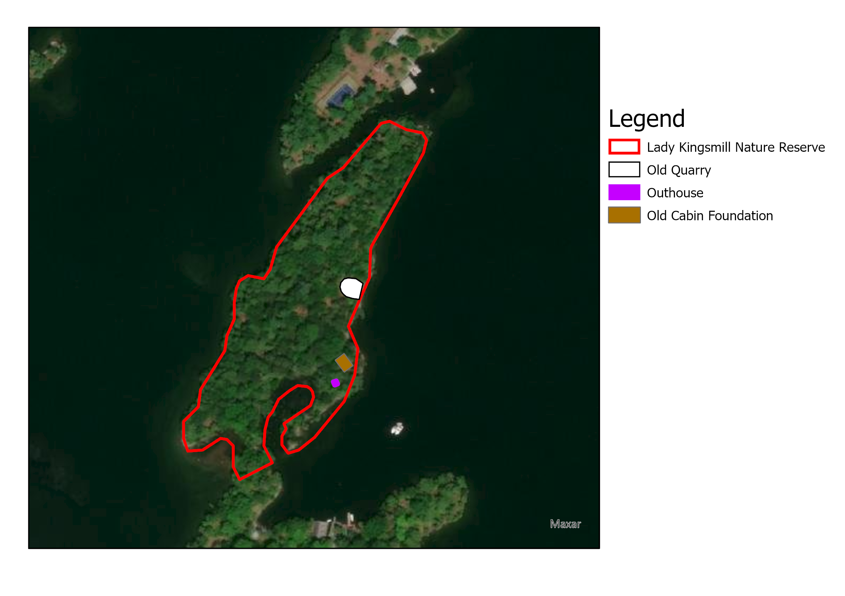
Figure 1: Satellite Imagery of Lady Kingsmill Nature Reserve

Location
Lady Kingsmill NR is located on Big Rideau Lake in the Township of Rideau Lakes and falls in the Geographic Township of South Burgess. For the location of Lady Kingsmill NR relative to other RWLT properties, see Figure 2 below.

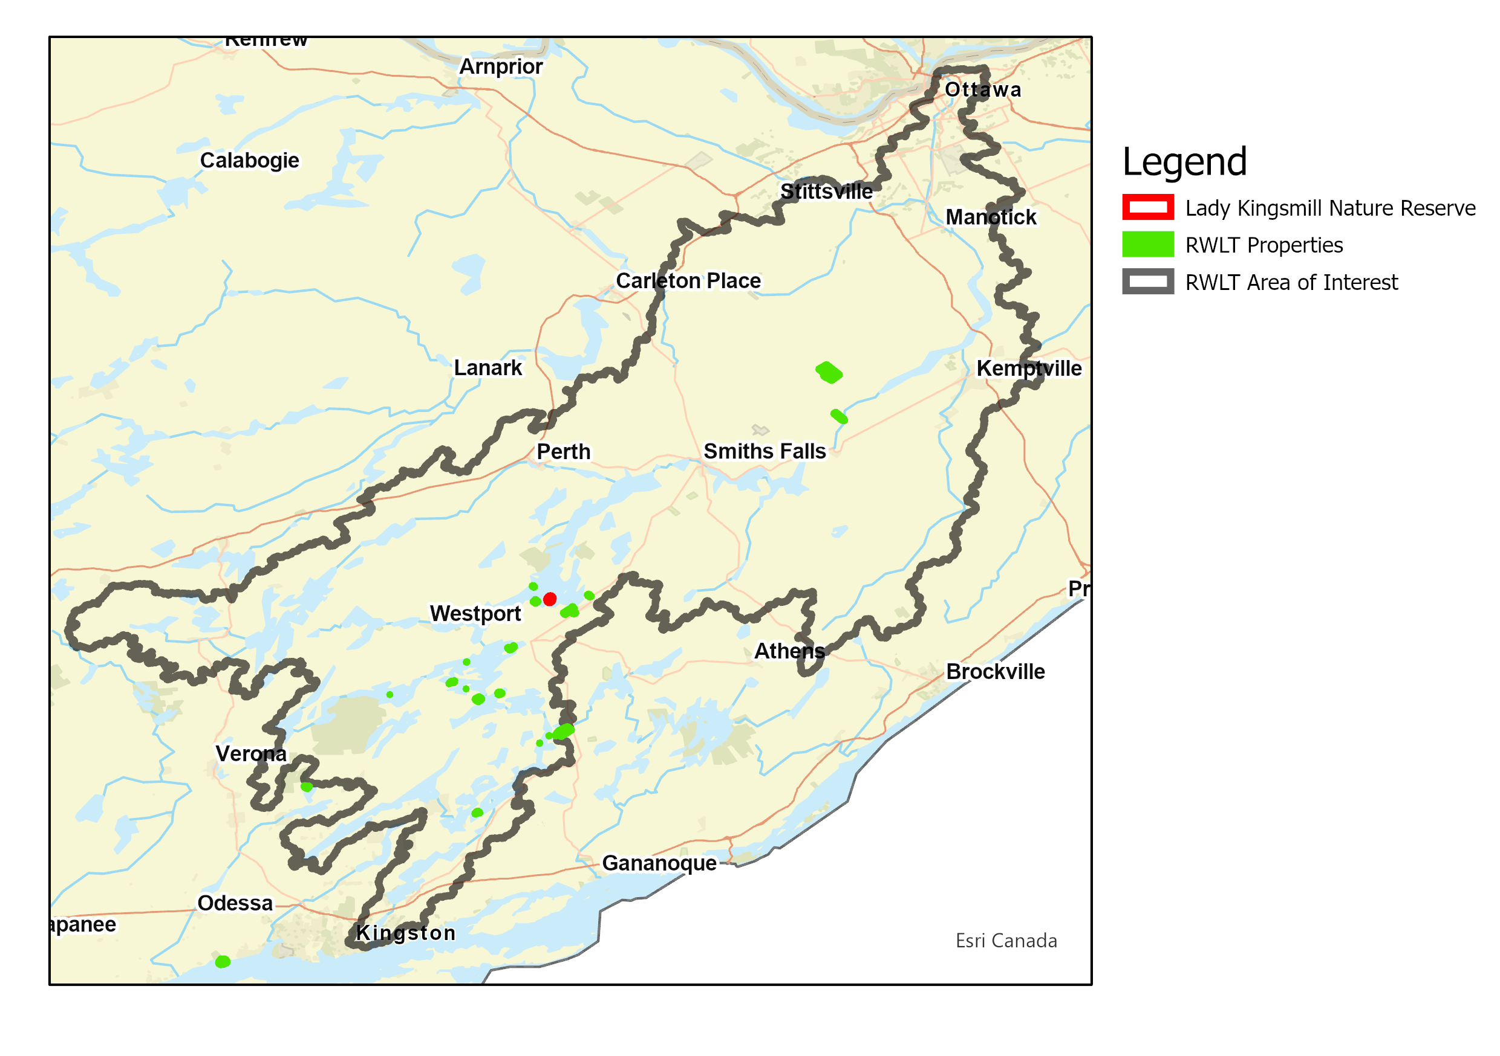Figure 2: Regional Locator Map of Lady Kingsmill Nature Reserve

Property Area
Lady Kingsmill NR is a 2.41 hectare (5.96 acre) property that makes up half of a larger island called Grindstone Island (~5.17 hectares or 12.78 acres).

Securement Type/ Year
Lady Kingsmill NR was acquired in 2011 as fee simple donation.

Key Local Partners
Key local partners in the management of Lady Kingsmill NR include:

- Neighbour – the neighbour to the Lady Kingsmill NR property who lives on the Southern section of Grindstone Island. She is able to keep an eye on Lady Kingsmill NR as she spends a considerable amount of time at her own property. Her observations of Lady Kingsmill NR have been recorded in this document and have helped to inform the management plan.
- Parks Canada – in charge of the management of Big Rideau Lake. They helped us to delineate the property’s boundary.
- Bob Rae – donated the Lady Kingsmill NR property to the RWLT. He is also a prominent figure throughout Canada as a Canadian Diplomat, public speaker, lawyer, former politician and the current Canadian Ambassador to the United Nations. He has also been awarded a place as the honorary chairman of the RWLT board.

*Note: Contact information for key partners can be found in Appendix C: Contact Information for Key Local Partners

Biodiversity Values
Lady Kingsmill NR is home to a wide range of species of flora and fauna. A brief summary can be found below, with further details in Section 5.2: Biological Features, found on page 16.

Species Type | Number of Species
Amphibian | 2
Bird | 25
Invertebrate | 0
Mammal | 7
Plant | 8
Reptile | 1
Tree/Shrub | 12

Species of Concern | S Rank (Ontario) | N Rank (Canada) | G Rank (Global)
Northern Map Turtle | S3 | N3 | G5
American Bullfrog | S4 | N5 | G5
Great Blue Heron | S4 | N5B, N3N, N5M | G5
Trumpeter Swan | S4 | N5B, N5N, N5M | G4
American Mink | S4 | N5 | G5
Andrews' Bottle Gentian | S4 | N4, N5 | G5
Canada Yew | S4 | N5 | G5

*Note: A rank of 1 = Critically imperiled, 2 = Imperiled, 3 = Vulnerable, 4 = Apparently Secure, 5 = Secure; B = breeding, N = nonbreeding, M = migrant

Conservation Targets and Threats

Conservation Targets/ Overall Viability Assessment
The two conservation targets identified on the property are 1. the forest and 2. the shoreline and adjacent wetlands.
Target | Overall Viability | Explanation
Forest | Good | The forest health was actually very good due to the low number of non-native species (only European Lily-of-the-Valley) and high diversity of species, layer and tree size. The overall viability was only brought down from ‘very good’ to ‘good’ due to the high percentage of trees disease/damage from Gypsy moths.
Shoreline and Adjacent Wetlands | Good | The overall health of wetlands and adjacent shoreline health is good due to the combination of good open water to vegetation ratio (80% vegetation, 20% open water) and low number (2 species) and cover of invasive non-native species (1-15% cover).

Highest Threats
The major threats to these conservation targets are climate change, garbage and solid waste and human disturbance via boating and trespassing.
Target | Two Main Threats | Explanation
Forest | Human disturbance  Climate Change | People have been seen trespassing on the property. Trespassing can introduce invasive species and garbage and disturb wildlife. So far only one invasive species (Lily-of-the-Valley) has been found in the forest, although it’s difficult to say whether it was introduced from human trespassing or some other means. Some garbage has also been found throughout the forest.  Climate change is likely to affect the forest through species range shifts, strong winds and pests. It can also compound existing threats. As examples, stronger winds may introduce more garbage and species range shifts may allow new invasive species to establish themselves on the island.
Shoreline and Adjacent Wetlands | Human disturbance  Climate Change | Trespassing on the property also affects the shoreline and disturbs its vegetation while large waves from boats contribute to shoreline erosion. Shoreline erosion is an obvious issue in the eastern wetland. There are also two invasive species that can be found in the wetland: Water Forget-Me-Not and Canada Thistle.  Climate change will likely impact the wetland through increased water temperatures, reduced soil moisture in the fall and species range shifts. Climate change will also likely compound existing issues with invasive species and garbage through warmer water temperatures and stronger winds.

Conservation Management Goal and Objectives
The RWLT objectives for Lady Kingsmill NR include:

- Preventing some invasive species found in 2021 from spreading beyond the 2021 limits, while eliminating others
- Carefully monitoring the shoreline erosion to make sure the habitat provided by the shoreline and the wetlands is preserved
- Discouraging human activity on the property

Five-year Budget Summary
The total cost to implement this management plan is $13,785 over five years or approximately $2757 per year. For information and cost estimates related to stewardship beyond the scope of five years, including the plan update for 2026, see section 8.3 which provides a budget for a 25 year period. All cost calculations are based on rates from 2021 and are subject to change.

Urgent Actions
Description |  | Frequency | Cost
Property Maintenance | Perform tasks as needed to keep property in good condition ecologically and functionally  - Remove invasive species | Annually | $656/year
 |  | Total Over 5 Years | $3,278

Necessary Actions
Description |  | Frequency | Cost
Property Taxes and Insurance | Property taxes and insurance  - Register property under CLTIP CCL  - Maintain insurance policy  - Pay property taxes if the entire property is not eligible under CLTIP  - Liaise with municipalities/MNRF/MPAC | Annually | $128/year
Property Signage | Maintain and replace signage as needed, assuming 10 year replacement period | Every 10 years | $190/10 years
Annual Monitoring | - Conduct annual monitoring visit and complete form  - Where appropriate, this visit can also include the following:  - Invasive species inventory  - Long term snake monitoring  - Record incidental SAR  - Record all species encountered | Annually | $655/year
Bi-Annual Monitoring | Bi-Annual Monitoring (in addition to annual monitoring)  - Breeding Bird Surveys  - Amphibian Surveys  - Marsh Monitoring (where possible)  - Vernal Pool Surveys | 2021, Every 2 years | $655/2 years
Reports and Database | - Draft any invasive species or SAR reports  - Update species database  - Plan visits | Ongoing | $756/year
Partner Liaison | - Keep in contact with Parks Canada and southern neighbour | Ongoing | $216/year
 |  | Total Over 5 Years | $10,513

Background

Purpose of the Management Plan
The Rideau Waterway Land Trust acquired Lady Kingsmill Nature Reserve in 2011 with the intent that the Land Trust would manage the land to protect its natural features and ensure the proper and continuing conservation of the land.

The majority of the information on Lady Kingsmill NR was retrieved from the narrative appraisal report of the property (Powers, 2011) or from the donation information collected to apply for the Eco Gift program (Lunn, 2011).

The scope of the property management plan for Lady Kingsmill NR is place-based, focusing on the property, the shoreline and the adjacent wetlands. This management plan describes how the organization will manage the property over the next five years.

Rideau Waterway Land Trust’s Conservation Efforts
There are no reports documenting how the RWLT decided to accept Lady Kingsmill NR as a donation; however, it does meet the 2008 land acquisition criteria that the RWLT was using at the time of property’s acquisition (RWLT Board of Directors, 2008). First, the size of the property (2.41 hectares) exceeds the minimum suggested size of 0.2 hectares (0.5 acres). The property is also considered to be an important cultural landscape since it is situated within the immediate viewscape of the Rideau Canal, which is recognized as a World Heritage Site and a Canadian Heritage River. The property’s interesting history also adds to its cultural value.

The characteristics of Lady Kingsmill NR also align with some of RWLT’s new criteria (Fiedler and Spang, 2021), since it has a high likelihood of being developed and it protects wetland habitat. Lady Kingsmill NR’s proximity to Portland and to marinas makes it a desirable location for cottagers. Had the RWLT not acquired this property, it likely would have been developed for residential purposes. The RWLT’s protection preserves the ecological value of this property as well as the adjacent wetland habitat.

To date, there have been very few stewardship actions on the property, apart from annual monitoring visits. The only exception to this is when the cabin on the property was taken down and removed to decrease public interest in trespassing onto the property (removed in either 2011 or 2012).
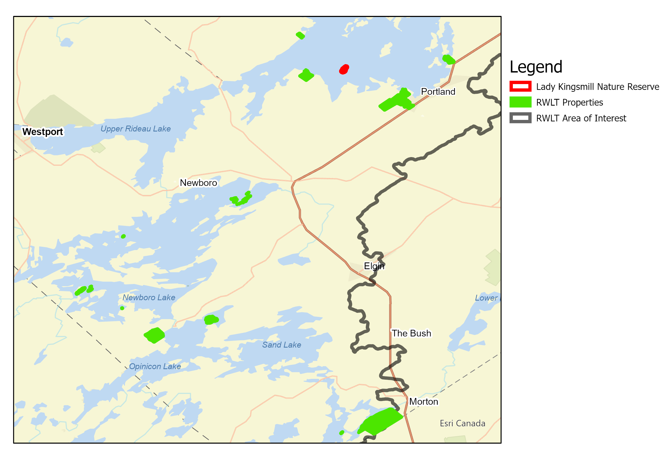Figure 3: RWLT Properties Concentrated around the Rideau Lakes.

Lady Kingsmill Nature Reserve Vision and Goals
Our vision for Lady Kingsmill Nature Reserve is that its protection and management as a conservation land not only encourages a flourishing forest community but also preserves a naturalized shoreline and wetland habitat for birds, fish and herptiles.

The long-term vision for the property is to steward and maintain the health of conservation targets, reduce or eliminate threats, and support species at risk.

Property Description
Table 1: Lady Kingsmill NR Property Specifications
Legal Description | Con 1 PT Lot 18 PT Lot 19 PT Island 24 RP 28R1398
Year Secured | 2011
Property Owner | Rideau Waterway Land Trust
Property Manager | Rideau Waterway Land Trust
Nearest Major City Centre | Portland, Ontario
Directions | Take highway 15 to the boat launch at Portland. A boat can be launched here to reach the island. Use a map to navigate to Lady Kingsmill NR (should only take 10 minutes on a motorboat and 45 by canoe approximately). The property will be labelled as Grindstone Island on maps. A slightly closer canoe launch is Peter Hannah’s house (current board chair). His house is located at 3614 R36, Portland, Rideau Lakes, ON. Staff are able to park in the extra parking spot in front of his house.  Staff may also try requesting access to the water from the residents around:  - 4214 Murphy Bay Rd property  - 5012 Sherwood Rd  - 4399 Sherwood Rd
Coordinate Reference | 44.712431, -76.231133
Elevation | Lake level: 123-124 m ASL  High point of property: 129 m ASL  Peak height above lake level: 5-6 m ALL
Surface Area | 2.41 hectares (5.96 acres)
Conservation Authority | Rideau Valley Conservation Authority
Watershed | Rideau River
Eco District | Georgian Bay 5E-11
MNRF District | MNRF’s Southern Region, Kemptville District.  -Address: Unit 1, 10 Campus Drive, Kemptville, ON K0G 1J0  -Phone: 613-258-8204
Assessment Roll Number | 08 31 831 051 05201
Property Identification Number | 44125-0102 (LT)

Description of Property Perimeter Boundaries
The property is a small section (2.41 hectares) of a larger island (total area ~5.17 hectares), located about 600 m north of Sheldon’s Point off the south shore of Big Rideau Lake, near Portland in eastern Ontario (lat, long: 44.712651, -76.231027). The property makes up the northern half of Grindstone Island which is separated from the southern portion by a small naturally vegetated isthmus. The southern portion of Grindstone Island is occupied by an active cottage. The property is further bounded by Plum Island (~2.0 hectares) on its northern flank and surrounded otherwise by the waters of Big Rideau Lake.

Site Designations
Lady Kingsmill NR is not designated as a significant area by the township, provincial, or federal government. The property is identified as part of the Natural Heritage System on Appendix 2 to the Official Plan of the United Counties of Leeds & Grenville.

Agreements (leases, encumbrances, etc.)
Lady Kingsmill NR was donated under the Ecological Gifts Program (EGP). As the recipient of an Ecological Gift (EcoGift ID: ON 478), the RWLT is required to uphold recipient responsibilities under the federal EGP. This includes maintaining current land-use consistent with the original objectives of the Ecological Gift. The penalty for an unauthorized disposition or change in use of an Ecological Gift is a federal tax equal to 50% of the current fair market value of the land (Environment Canada, 2011). The entire property is registered for Conservation Land Tax Incentive Program (CLTIP) as a Community Conservation Land (CCL). The CCL category broadens the range of properties owned by Conservation Authorities or like-minded organizations that are eligible for a property tax reduction. No use that would be detrimental to the natural heritage values of the property is permitted on a property registered under CLTIP (Ontario Ministry of Natural Resources, 2014). RWLT is required to reapply annually for properties registered in this program.

Adjacent Land Use and Cultural Elements
To the south of Lady Kingsmill NR lies the southern portion of Grindstone Island which is currently owned and used as a summer cottage. This section of the island is more developed than Lady Kingsmill NR with many of the trees cleared in the early 1900’s. It includes a number of cottages, outbuildings, and other structures. The island north of Lady Kingsmill NR is known as Plum Island and has an existing cottage. This type of use is dominant along the south shore of Big Rideau Lake.

There are four other RWLT properties situated around Big Rideau Lake: Red Rock, Sherwood Bay, Edwards Wetlands and MacDonald’s Island Wetland. The closest property is Sherwood Bay which is 1 km south of Lady Kingsmill NR on the mainland. Red Rock and Edwards Wetlands are both about 2.5 km south of Lady Kingsmill NR, although the vast majority of Edwards Wetlands is slightly inland and does not include the shoreline of Big Rideau Lake. The last property on the lake is MacDonald’s Island Wetland, which is about 4 km east of Lady Kingsmill NR. All four of these properties are well-forested areas but Red Rock features an open rocky shoreline with an osprey platform, Edwards Wetlands contains a large wetland and MacDonald’s borders a shoreline wetland.

Property Management

Historical Land Use
The first known use of Grindstone Island was as a quarry in the mid 1800’s. The remnants of this quarry can still be seen on the east side of the Lady Kingsmill NR property today. In 1916, Admiral and Lady Kingsmill started using the Grindstone Island as their summer home where they hosted a number of noteworthy guests including Sir Robert Borden and Lady Borden, David Niven (actor), the Duke and Duchess of Devonshire and Neville Chamberlain. A number of cabins and lodges were built on the island although the majority of these were built on the lower parcel which is not owned by the RWLT. Only one cabin was built on the parcel owned by the RWLT. This cabin was taken down when the RWLT acquired the property. Now, only the foundation and an outhouse remain. Once both Lady and Admiral Kingsmill had passed, the island was inherited by the Kingsmill children who did not readily use it themselves. Instead, the island was lent to the Quakers, a historic peace church. They formed the Canadian Friends Service and developed a non-profit peace education centre on the island. The island was the centre for a number of peace conferences and non-violence training institutes. In the 1980’s the island hosted a summer camp for children. Most of these activities were hosted on the lower section of the island, currently owned by the neighbour, and it is unclear how much of these activities included the use of the property now owned by the RWLT.

Acquisition History
The property was transferred from Robert Rae to RWLT on December 16, 2011. Mr. Rae originally purchased Lady Kingsmill NR from George Gordon-Lennox in 2001 and then donated the property to the RWLT as an Ecological Gift.

Current Management
There is no current management plan or active management taking place on the property apart from regular monitoring further described in Section 4.5.

Future Acquisitions
RWLT intends to maintain ownership of the property for the foreseeable future for conservation. There are currently no future acquisitions planned for the remaining portion of Grindstone Island adjacent to Lady Kingsmill NR or for the nearby lands along the shoreline. RWLT hopes to continue to acquire properties surrounding Big Rideau Lake as opportunities arise.

Stewardship
RWLT stewardship is carried out predominantly by the biology staff. These individuals visit the property at least once each year completing a standard monitoring worksheet (Appendix B). Each year, the visit is done during a different season to account for the full variation in flora, fauna and habitat. Winter monitoring will not be an option since boat access is not possible during the winter. Instead monitoring will have to alternate between late spring, mid-summer and early fall. Monitoring staff will report any unwanted and illegal activity to the RWLT board, and the organization decides the actions necessary to address any concerns. On the occasion that staff cannot make it to the property for a given year, board members may also visit the property to provide an update on the property even if it is less in-depth. Instead they may follow the monitoring report template and focus on inspecting for threats like trespassing and other incompatible uses rather than collecting biological information. Additional updates on the property may be provided by the neighbours on the southern section of the island. Maintaining a relationship with the current and future owners of the adjacent parcel is an important component of stewardship and long-term conservation of this property.

Baseline Inventory Summary

A formal baseline documentation report for Lady Kingsmill NR was never completed. However, a fairly detailed description of the property was written during the acquisition of the property for its certification as an Ecological Gift (Lunn, 2011).

Physical Features

Geology
Lady Kingsmill NR, along with the rest of Grindstone Island, is underlain by sedimentary rocks of the Metamorphic Series- primarily crystalline limestone and dolomite, with some siliceous limestone and rusty gneiss. A small graphite mineral pit was documental by Natural Resources Canada, which is still visible on the island and occupies approximately 0.05 hectares at the northeastern corner of the island. Evidence of the mineral pit exists today in two rock piles, a small rock face exposure and a large bowl-shaped depression (cut). The property reaches an elevation of over 6 m above lake level at its centre, but is most notable at its northern corner.

Soils
There is no documentation recording the soil type at Lady Kingsmill NR, although the Mississippi-Rideau source protection region reports that the region’s soils consist of approximately 2 m of loam. It is likely that there is less than 2 m of soil on Lady Kingsmill NR itself but no official survey has been conducted and this estimate is regional.

Surface Hydrology
As an island in the middle of Big Rideau Lake, the property is part of the Rideau Lakes Sub watershed which is a part of the Rideau Valley Watershed. Big Rideau Lake has a cold-water regime which, is important for improving water quality, maintaining biodiversity in the region and protecting species at risk. The property also lies within an area that is identified as a significant groundwater recharge area. This means that water in the area travels to our groundwater more quickly than in other areas and has more significant impact on groundwater quality.

The highest part of the property is about 6 m above lake level along the eastern coast. The terrain depresses gradually from the point to the western shoreline and depresses more quickly to the eastern shoreline. For the most part, very little water collects on Lady Kingsmill NR and instead runs directly into the lake since there are few depressions on the property. The main exception here is the quarry which may accumulate water in the spring and during heavy rainfalls. There is also a wetland on the southeastern side of Lady Kingsmill NR which is protected by a small patch of land and the water is likely much more stagnant.

Climate
Lady Kingsmill NR falls just within the southeastern boundary of ecoregion 5E-11 (Georgian Bay Ecoregion). The climate for this Ecoregion has been described as cool-temperate and humid. The region is cooler (mean annual temperature range: 2.8 - 6.2˚C), more humid and experiences more annual rainfall (mean annual precipitation range: 771 - 1,134 mm) than the lake Simcoe-Rideau Ecoregion (Crins et al., 2009).

Biological Features

Land Cover
The Lady Kingsmill Nature Reserve was previously listed as 85% forest and 15% wetland (Powers, 2011). However, contact with Craig Cunningham and Shawna Kenny (see Appendix C for contact info) from Parks Canada has verified that the summer waterline marks the boundary between the RWLT property and the lakebed, which is Crownland. Consequently, the wetland does not count as a part of the property. Therefore, the property is approximately 95% forest and 5% shoreline and riparian vegetation.

It is notable that the shoreline surrounding the property is in a natural state. With the exception of the sedge/bulrush (not cattails) dominated marshy inlet, lakebed substrate adjoining the island is a mixture of sand, clay and occasional cobblestone, with scattered native submergent vegetation and very occasional in-water deadfall.

Flora
The forested property is covered primarily by mixed woods, including an overstorey of dominant middle-aged coniferous (white pine, eastern hemlock, white cedar) and hardwood (basswood or linden, several large red oak and red maple) trees with younger specimens of eastern white cedar, white birch, ash, American beech, sugar maple, American elm and ironwood scattered throughout. The tree canopy along the southwestern side of the property is dominated by conifers, especially hemlock. Much of Lady Kingsmill NR is covered with a rather thick and robust understory of ground hemlock or Canada Yew, with dogwood shrubbery found at the southern end of the property, particularly surrounding the marshy bay (Powers, 2011). Previous documentation of the property’s vegetation also mentions a small and open treed rocky barren area adjacent to the middle of the property’s eastern shoreline, roughly 0.1 hectare in size and a significant but albeit small sedge/bulrush marshy inlet bay approximately 0.3–0.4 hectare in size. However, while there were a couple of small open patches, overall there was no prominent open area as described above. We believe these patches have grown in.

Fauna
Lady Kingsmill NR provides habitat for a range of fauna including 35 avian species, 7 mammalian species, 2 amphibian species and 1 reptilian species (see Appendix A for full list). The mammals observed on the property are almost exclusively from either the Mustelidae family (e.g., minks, otters) or the Rodentia order (e.g., beaver, grey squirrel). The exception to this is that there are also a few deer that inhabit the island. The 2021 targeted surveys detected amphibians and reptiles like the Northern Map Turtle, the Green Frog and the American Bullfrog. The Northern Map Turtle is currently considered a species of “special concern” by the Ontario Government. No other species at risk have been detected on the property.

Invasive Species
Table 2: Invasive Species found at Lady Kingsmill NR
Common Name | Date Observed | Description
Water Forget-Me-Not | June 17th 2021 | Observed by RWLT staff at the edge of the eastern wetland
European Lily-of-the-Valley | June 17th 2021 | Observed by RWLT staff near the foundation of the old cabin
Canada Thistle. | June 17th 2021 | Observed by RWLT staff along the shoreline of the eastern wetland
Gypsy Moths | June 17th 2021 | Observed by RWLT staff throughout the entire property as they are present throughout most of southern Ontario

Conservation Context
Lady Kingsmill Nature Reserve is one of the few undeveloped properties on Big Rideau Lake. Consequently, it is one of the few locations on the lake that features naturalized shoreline and undisturbed forest which is very important for flora and fauna in the area. Big Rideau Lake is a cold-water lake which is important for improving water quality, contributing to the maintenance of biodiversity in the region and helping protect species at risk. The RWLT is legally obliged to ensure the conservation of this property since it was donated under the Ecological Gifts Program.

Protected Areas and Environmental Designations
Except as noted in section 5.3.2 of this PMP, Lady Kingsmill Nature Reserve does not include any lands with an official environmental designation nor does include any lands that have been designated protected areas by any organization other than the RWLT. Along Big Rideau Lake there are a number of other protected lands most of which are other properties owned by the RWLT (see Figure 4). These properties include Red Rock, Sherwood Bay, Edwards Wetlands and MacDonald’s Island Wetland. There is also a considerable amount of Provincially Significant Wetland (PSW) that starts in Portland, not too far from the Edwards property, and continues throughout most of the eastern coast of Big Rideau Lake. Additional PSWs can be found on the mainland along the northwest coast. A provincial park, called Murphy’s Point is also located on the mainland directly north of Lady Kingsmill NR. Finally, the Rideau Valley Conservation Area owns a conservation land located along Highway 15 northwest of Portland called Portland Bay Conservation Area.

Policy Areas

Official Plan of the United Counties of Leeds and Grenville

According to the Official plan of the United Counties of Leeds and Grenville, Lady Kingsmill Nature Reserve has been designated a rural land. Most of the mainland along Big Rideau lake has been designated rural lands, with the exception of some inland agricultural land to the west, a rural settlement area to the south (Portland) and scattered provincially significant wetland to the east.

Section 4.2.12, Crown Lands, Conservation Lands and Significant Local Features, contains general policies applicable throughout the United Counties, including a statement encouraging the activities of land trusts.

The Official Plan of the United Counties of Leeds & Grenville contains two additional sections relevant to this property, one of which is very supportive of land trust activities:
Schedule D identifies an abandoned mine using a triangular symbol, reflecting the presence of a small abandoned quarry. Section 5.3.3 discourages development near these types of sites.

Appendix 2 identifies the land as part of the County's Natural Heritage System. Section 4.3(k) encourages the "creation of a linked Natural Heritage System through the integration" of various publicly owned lands and (ii)" areas in the ownership of land trusts."

Official Plan of the Township of Rideau Lakes

The Lady Kingsmill Nature Reserve is located within the Township of Rideau Lakes. Prior to municipal amalgamation in 1998 it was located in the Township of Bastard and South Burgess.

The Official Plan of the Township of Rideau Lakes was adopted by Council on October 20, 2003 and approved by the Ministry on April 2, 2004. The subject land is designated Rural. The policies applicable to this designation are contained in section 3.7. Section 3.7.2 lists the permitted uses including conservation.

Section 2 of the official plan contains General Development policies applicable to the entire Township. Section 2.12, Crown and Conservation Lands, acknowledges that some conservation lands are owned or managed by non-profit organizations. These are permitted anywhere in the Township.

Zoning By-law #2005-6

Schedule A3 of the Township of Rideau Lakes Zoning By-law zones the subject land as waterfront Residential RW, reflecting its existing use at the time the By-law was passed. When an opportunity arises in the future to provide input into a new comprehensive zoning by-law, it may be appropriate to place the land in a category which limits the permitted uses to just a conservation use.

Others

The property also lies within the Rideau Valley Conservation Area although they have not publicly released any land designation information related to Lady Kingsmill NR.

Boaters on Big Rideau Lake must observe the speed limit of 10km/h within 30m of shore as dictated by the Vessel Operation Restriction Regulations (VORRs).

Landscape Context
The island is located on the southwestern portion of Big Rideau Lake. The area faces development pressures since it is a popular area for cottages. The area is also subject to high boat traffic since Big Rideau Lake is a segment of the Rideau Canal.
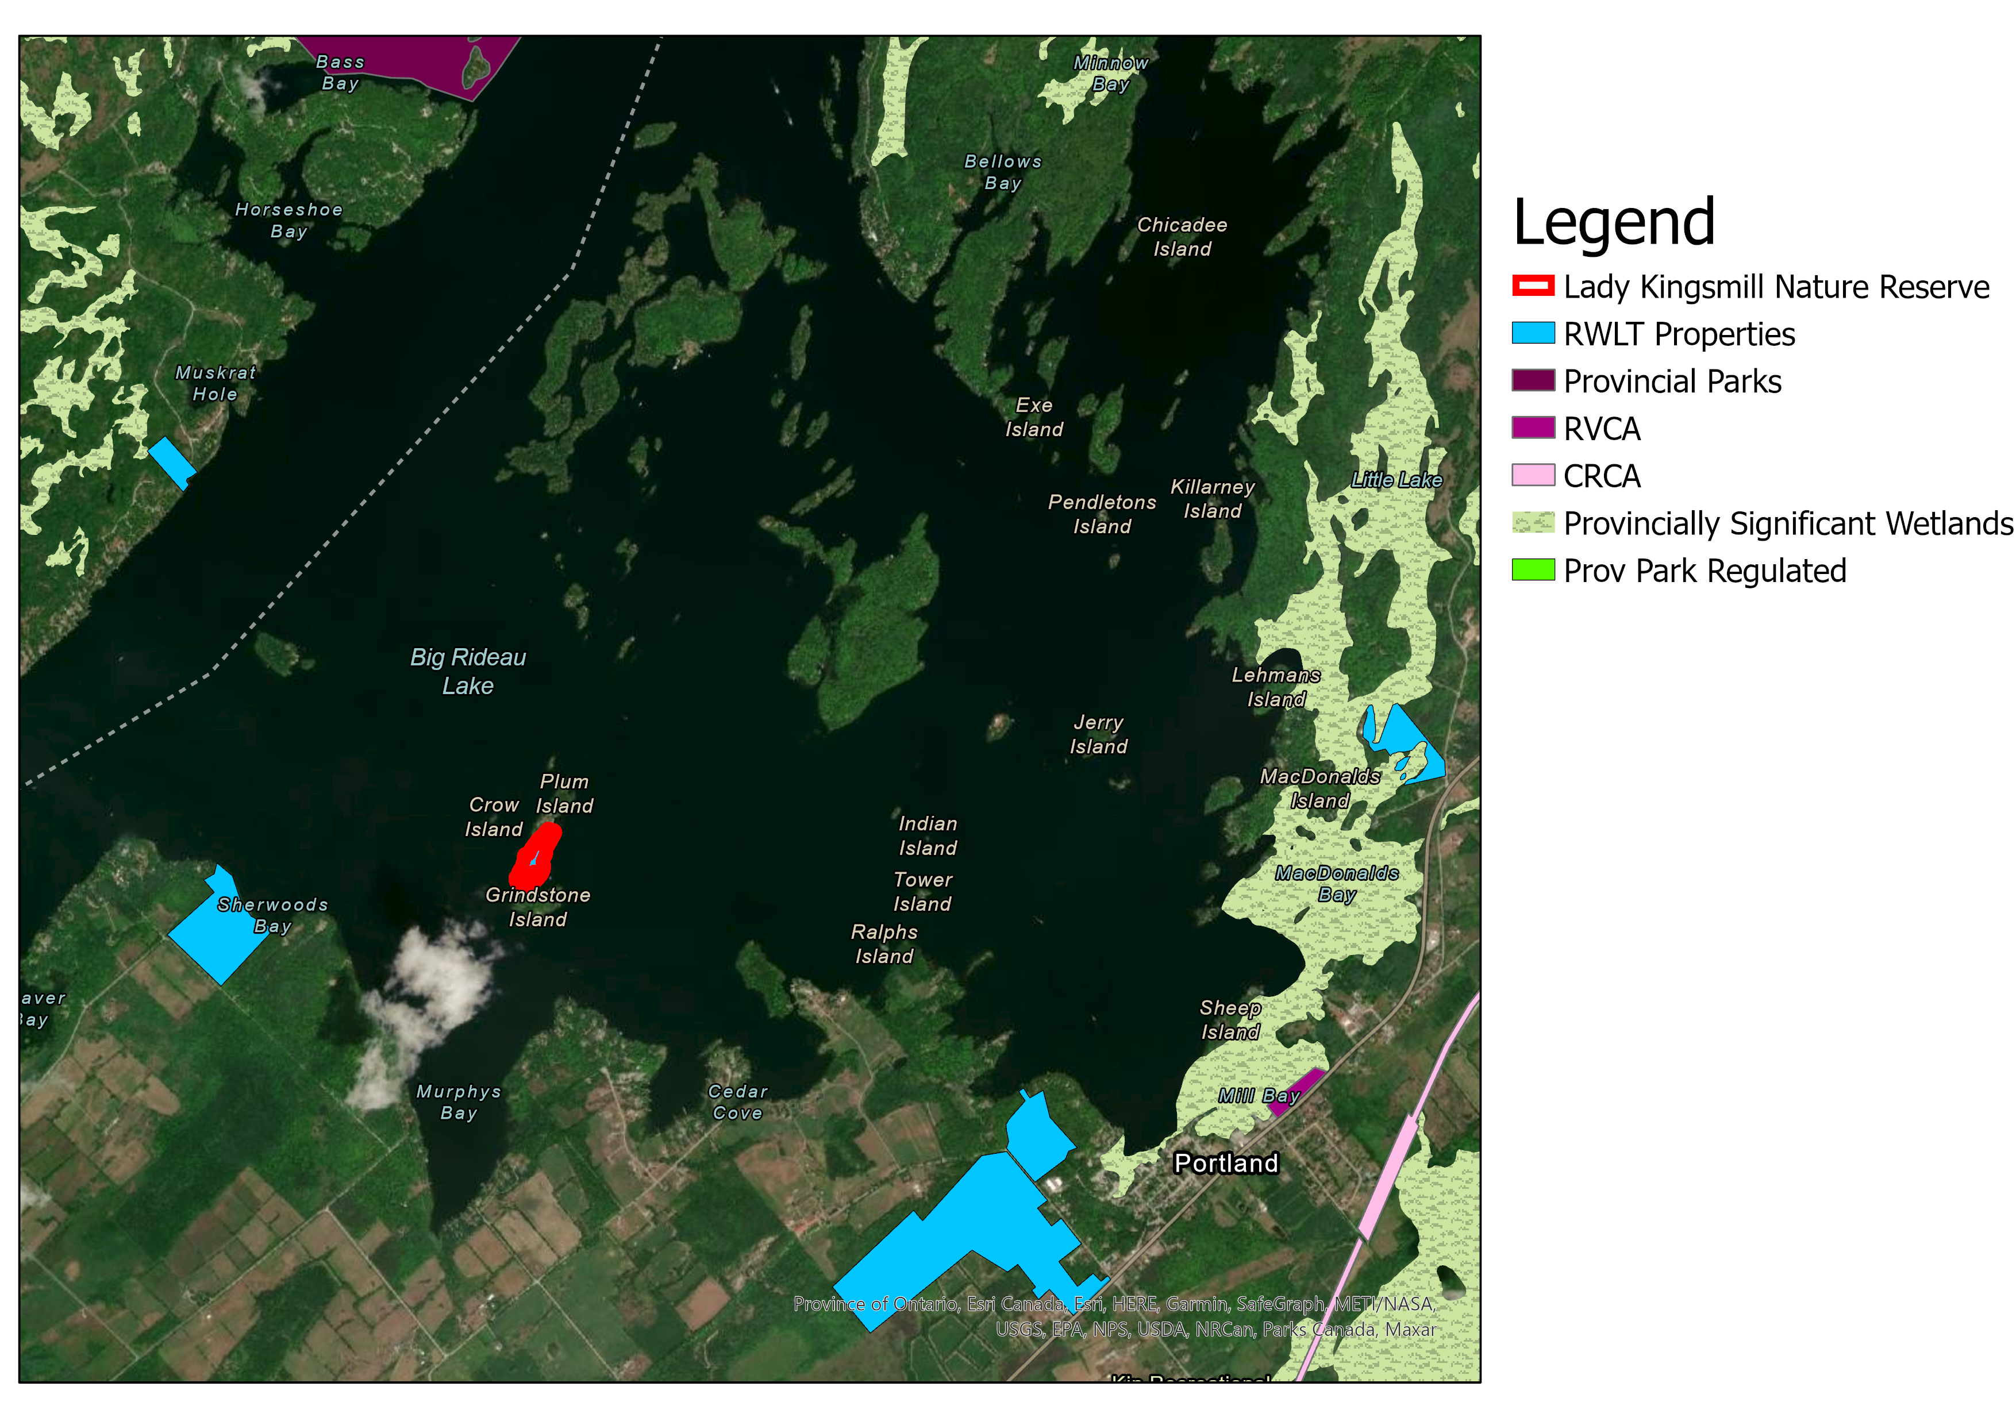
Figure 4: Protected Lands and Provincially Significant Areas surrounding Lady Kingsmill Nature Reserve

Conservation Target Analysis (Conservation Targets, KEA, Indicators)

The RWLT staff have worked collaboratively with the staff at the Ontario Land Trust Alliance (OLTA) to identify two main conservation targets on Lady Kingsmill Nature Reserve. The two identified conservation targets are the forests and the shoreline including the adjacent wetlands. Each of these conservation priorities is described below with a particular focus on their ecological significance. General assessment criteria are identified, and a rating assigned where possible.

Forests
The section of the PMP pertains to all forested areas lying within the Lady Kingsmill NR property boundary.

Ecosystem Description
The forest conservation target includes all sections of forest within the property boundary, which comprises 95% forest. The majority of the forest on the property is a mix of deciduous and coniferous trees. While both types are present across Lady Kingsmill NR, in general, the western side of the property is dominated mainly by middle-aged conifers like white pine, eastern hemlock, white cedar trees and the eastern side features more deciduous trees like red oaks, basswoods and maples. Much of Lady Kingsmill NR is covered with a rather thick and robust understory of ground hemlock or Canada Yew, with dogwood shrubbery found at the southern end of the property, particularly surrounding the marshy bay. The northern portion of Lady Kingsmill NR in particular is dominated by shrubs and with only a few mature trees occupying a canopy. The understory scattered throughout the property includes younger specimens of eastern white cedar, white birch, ash, American beech, sugar maple, American elm and ironwood scattered. Table 3 identifies vegetation communities found at specific survey points on the property. A full list of the plant species found on the island can be found in Appendix A.

Table 3: Vegetation communities at 4 survey points. These surveys were taken in 2020 from 4 well dispersed survey points. The accompanying map locating the survey points can be found on the land trust’s ArcGIS online account.
Survey Point ID | Latitude, longitude | Habitat Characteristics | Vegetation of Canopy | Vegetation Sub-Canopy | Vegetation of understory | Vegetation of floor
Kingsmill  survey_1 | 44.7117983,  -76.2317031 | edge of closed-canopy forest and wetland. wetland: cattails | red maple, basswood, white birch | hemlock | dogwood, white cedar | juniper, ferns, tall sharp grasses
Kingsmill  survey_2 | 44.712956,  -76.230892 | partly open canopy, mature mixed forest | red oak, white pine, white cedar, white birch | basswood | red cedar, sumac | sapling hemlock, Canadian yew
Kingsmill  survey_3 | 44.713776,  -76.230132 | open canopy, shrub area with some mature trees | white cedar, hemlock, dying basswood | NA | dogwood | NA
Kingsmill  survey_4 | 44.7120827,  -76.231115 | open canopy, edge of wetland and mixed forest | Hemlock, basswood, | NA | dogwoods, grapevine | grasses, cattails

Biodiversity
During the 2021 monitoring visit, the forest diversity was assessed by looking at three components: size diversity, layer diversity and species diversity (see table 4 of assessment results or Appendix E for data informing assessment). All three components were given a rating of ‘good’ according to the evaluation protocol (see Appendix C) (Project Learning Tree, 2012). There were only three rating levels in this evaluation protocol (poor, fair and good), while the rest of the features in this PMP are rated on four levels (poor, fair, good and very good). In this case the diversity rating for the forest should be considered very good. The forest diversity surveys along with the disease surveys were conducted according to the protocol outlined in “Monitoring Forest Health” by Project Learning Tree. Note that there were many more diseases listed on the form but only the damage/disease found on the trees are listed in Appendix E (Project Learning Tree, 2012).

A number of bird species have been recorded on the property. During the monitoring visit in 2021 we found some of the following species throughout the forest on the property: Common Grackle, Northern Flicker, Black-capped Chickadee, Crow, Red-winged Blackbird, Swamp sparrow, Song Sparrow, Eastern Kingbird, and Eastern Phoebe. In 2020 we also observed the Barred Owl, Great Crested Flycatcher, Red-eyed Vireo and the White and Black Warbler. As for mammalian species, deer and squirrels are regular inhabitants on the island. Fishers have also been reported on the island in the past, but have not been sighted in a number of years (see Appendix A for full list of species).

Assessment
Table 4: Summary of the forest’s health and composition - focus its diversity, the presence of disease and damage and the presence of non-native species.
Type | Key Attribute | Indicator | Ranking | Notes
Condition | Community Composition | Non-native Species Richness | Very good | Three non-native species have been identified on the property and they not very widespread, although they are considered invasive. Data for the species present was taken from the 2020 monitoring report.
Condition | Community Health | Diversity | Very good | All 3 survey points were given a rating of 3 (good) for layer, species, and size diversity. The full table with the data for the assessment of each diversity type can be found in Appendix E.
Condition | Community Health | Percentage of trees with disease or damage | Fair | The very high percentage of trees with damage/disease is a direct result of the of Gypsy moth outbreak this year. The Gypsy moths are causing extreme defoliation throughout southern Ontario. Otherwise there are very few trees with damage or disease and community health would be rated “good” overall. The data from the disease/damage assessment can be found in Appendix E.
Overall Ranking |  |  | Good

Shoreline and Adjacent Wetlands
This conservation target refers to the entire shoreline that outlines the perimeter of the property, including all land within 3 metres of the boundary, as well as the adjacent wetland surrounding the property. There are two wetland areas at the southern end of the property on either side of the isthmus. Neither of these wetlands are actually situated within the boundaries of the property since the property ends where the water begins; however, the island and how it’s managed has a significant effect on the wetlands. Arguably, one of the main values of the property is that it protects and prevents the development of the shoreline on a largely well-developed lake.

Ecosystem Description
The shoreline of the property is predominantly made up of small and large stones. The rocky perimeter occupies approximately a 1-3 metre belt around the property before the inland terrestrial vegetation begins.

The wetland on the eastern side of the property is situated in a cove protected by an arm of land that extends south off the island. This arm of land likely provides significant protection from turbulent water and has allowed vegetation to grow in. This wetland is 70% vegetation and 30% open water. Two non-native species were spotted in the wetland: Water Forget-Me-Not and Canada Thistle.

The wetland on the western side is less enclosed and is less vegetated. This wetland feature is 80% open water and 20% vegetation.

Biodiversity
Bird species found in wetlands in 2021 include the Great Blue Heron, Red-eyed Vireo, Eastern Kingbird, Northern Flicker, Pileated Woodpecker, Common Grackle, Song Sparrow, Common Loon, American Robin, Great Blue Heron, Trumpeter Swan, Black-capped Chickadee and Mourning Dove.

Amphibian species on the property include the Green Frog and the American Bullfrog. As for reptiles, we found a Northern Map Turtle (see Appendix A for specific location). Mammalian sighting in the wetlands and along the shoreline include mink, otter, muskrat and beavers. These mammalian species have all been reported by the neighbour.

Assessment
Table 5: Assessment of the habitat diversity and species composition in the Wetlands.
Type | Key Attribute | Indicator | Ranking | Notes
Eastern Wetland
Condition | Habitat Diversity | Open water to vegetation ratio | Good | 70% open water, 30% vegetation
Condition | Species Composition | Non-Native Species Richness | Very good | None
Condition | Species Composition | Relative Cover of Non-native Species | Very good | 0%
Western Wetland
 | Habitat Diversity | Open water to vegetation ratio | Good | 80% vegetation, 20 % open water
Condition | Species Composition | Non-Native Species Richness | Very good | Only two species found (>5 species)
Condition | Species Composition | Relative Cover of Non-native Species | Good | 1-15% cover of the vegetation
Overall Ranking of both Wetlands |  |  | Good

Threats

Human Intrusions & Disturbances

Recreational Activities - Boating
Big Rideau Lake experiences a considerable amount of boat traffic since, being a segment of the Rideau Canal, it is a popular lake for cottagers and also for tourists. One of the major drawbacks to the high boating activity is that it can cause soil erosion at the shoreline. Soil erosion has been identified as an issue on the island by the neighbours. Additionally, the noise from the motors of the boats can disturb the sensitive ecosystems along the shoreline and in the wetlands. To mitigate the effects of motorboats on the shorelines and their habitats, a speed limit has been put in place to mandate that boats should not make a wake within 30 m of the shoreline. Unfortunately, the neighbour on the southern half of the island has reported that many boaters do not observe that law and often drive fast and close to the shoreline along Lady Kingsmill NR. The major issue is with large cruisers and wakeboard boats which purposefully create large wakes. The neighbour explained that this is typically happening along the west side of the island.

Recreational Activities - Trespassing
The neighbours reported trespassers visiting the island more frequently in recent years. The trespassers are usually casual boaters or fishers who come ashore to picnic or explore the island. The neighbour has spoken to the people trespassing on the islands and has also discussed the issue of trespassing with the owner of a particularly popular Airbnb in the area. The owner of the Airbnb has stressed to their visitors that the islands in the area are private.

It is important to minimize trespassing on the property since it could have a variety of consequences including dumping, introducing invasive species, disturbing wildlife and disturbing the shoreline. Invasive species in particular can be a major threat to ecosystems since they often outcompete native species which can result in a decrease in biodiversity in a given area. Luckily at this point, only three invasive species have been documented on the island.

Garbage and Solid Waste
Garbage has accumulated on Lady Kingsmill NR from trespassers visiting the property and from regularly washing ashore from the lake. The trash usually includes bottles, cans and plastic garbage. There is also a large tire embedded in the ground along the east shore that would take significant effort to remove. For the most part, it seems that the garbage remains localized along the shoreline and does not continue far inland.

Invasive Non-Native/Alien Plants and Animals
Invasive species can outcompete native species which can result in a decrease in biodiversity in a given area. There are currently three known non-native species present on the island: Canada Thistle, Water Forget-Me-Not and European Lily-of-the-Valley. All three of these non-native plants are considered invasive in Ontario. Luckily the three species do not seem to be very wide-spread throughout the island and could likely be eliminated by manual pulling. There is a good chance that invasive and other non-native species will continue to be an issue on the property since they species can be introduced from garbage washing ashore and trespassers visiting the island. Invasive species may also be introduced to the island through other more natural methods of transport like through wind or on animals.

Climate Change
After completing a climate change vulnerability assessment, we identified that climate change would introduce new stresses on the conservation targets as well as compound the threats listed above.

Climate Change Threats to the Forest
The island’s forest would likely be affected by climate change via strong winds, species range shifts and increased pests and diseases. Strong winds are hard on trees since they cause trees to pull and sway, which stretches their roots. This movement can disrupt contact between roots and the surrounding soil resulting in a decrease in water absorption and cause severe water stress in trees. Wind has the potential to decrease leaf biomass and even eliminate forest layers (i.e. canopy, sub-canopy, understory and floor). Climate change will include a change in temperature regime. As the temperature increases, many species ranges will shift north, and there will likely be a corresponding increase in pests and diseases. New species often outcompete native species that may already be struggling with an introduced disease.

Climate Change Threats to the Shoreline and Wetlands
The property’s shoreline and wetlands would likely be affected by climate change through increased water temperature, reduced soil moisture in the fall and species range shifts. Lakes in the area are experiencing warmer temperatures each year. The increase in water temperature has been shown to increase algal blooms, cyanobacteria and other toxins which in turn decreases the light reaching aquatic plants. Each of these factors alone can stress native plants and make it difficult for them to grow while enabling non-native and invasive plants to thrive. The culmination of changing all these factors would cause significant effects on the native aquatic ecosystem. The Big Rideau Lake area has also been projected to experience more intense droughts throughout the summer. One of the major consequences of this is that the soils on the island would be much drier than usual and the upland wetland vegetation may not persist.

Climate Change Compounding Existing Threats
There are several climate change related factors that compound existing threats:
- increased strong winds in the area
- shifting species ranges
- increased pests and diseases
- changes in precipitation patterns and
- an increase in water temperature.

Strong winds can act as vectors for non-native species. Consequently, an increase in the frequency and intensity of strong winds will likely result in an increase of non-native and invasive species to the island. Strong winds can also cause stress to the native species and create disturbances where non-native species would have an opportunity to establish themselves. Strong winds may also bring more trash to the island property.

Shifting species ranges may introduce non-native species. Corresponding increases in pests and diseases will further threaten native species.

A change in the soil moisture regime, resulting from changes in precipitation patterns, would also likely facilitate the persistence of non-natives and their ability to thrive along the shoreline, since a change in soil moisture acts as a stress to native species.

An increase in water temperature will also likely increase recreational activity on the lake. Warmer water often attracts more boaters to the lake, eager to enjoy the comfortable temperature of the water. It will also extend the length of the boating season. With the water warming up sooner in the spring and cooling off later in the fall, boaters will likely push the season as long as they can. The consequence of this is that shorelines are exposed to wakes from boating traffic for a longer time, potentially increasing shoreline erosion.

Management Goal, Objectives and Actions

Management Goal
RWLT’s goal for Lady Kingsmill Nature Reserve is to preserve its ecological integrity through stewardship and management. Lady Kingsmill NR is one of the few properties on Big Rideau Lake that has not been developed as a residential area and is protected from this development in the future. The RWLT aims to continue to preserve the forest and adjacent wetland of the island as it provides habitat for many species in the area. This becomes vitally important as the rest of the area inevitably becomes increasingly developed and experiences higher boating traffic.

Stewardship Actions
Table 6: Planned Stewardship Actions - the actions laid out to continue effective management of Lady Kingsmill Nature Reserve. These actions were compiled based on the Conservation Actions Classification (V2.0) created by the Conservation Measures Partnership (Stewart et al., 2020). The priority of the actions has been indicated with colour, where red represent high priority, orange represents medium priority and yellow represents low priority.
Action Category | Description | Target(s) | Threat(s) | Measure of Success | Frequency
Land/water Management | Monitor property boundaries for evidence of trespass, threats, risks and liabilities | Forest and Shoreline/ Wetland | All threats listed in section 6 | - Annual monitoring visits to check property. This includes monitoring the property boundary, changes to the land, evidence of trespassing, SAR, invasive species and other threats.  - Complete monitoring forms and store species lists in the species list database. Any issues and threats will be addressed. | Annually
Land/water Management | Monitor property for invasive species | Forest and Shoreline/ Wetland | Invasive species | - Conduct property inventories to document location and extent of invasive species on the property and develop an action plan.  - Action plan will mitigate impacts of invasive species. Will help to expand understanding of the scope and severity of threat. | Annually
Land/water Management | Monitor the severity of soil erosion | Shoreline | Soil Erosion | - Measure soil erosion along the shoreline to track the severity of the issue and its progression | every 2 years
Land/water Management | Enforce no-wake zone/boat speed limit | Shoreline and adjacent Wetland | Soil erosion and disturbing the wetland habitat | - If soil erosion continues to get worse, consider contacting Parks Canada to request that a no-wake zone sign be installed around Lady Kingsmill NR | Installation – if erosion continues severely.  Monitoring - annually
Species | Maintain and update species list for the property | Forest and Shoreline/ Wetland | All threats listed in section 6 | - Annual monitoring visits should document all species identified on the property and in the adjacent wetland  - Update Species list and other relevant databases (GIS)  - Report SAR/tracked species to NHIC | Annually
Species | Breeding Bird Surveys | Forest and Shoreline/ Wetland | All threats listed in section 6 | - Undertake breeding bird survey and/or targeted SAR bird survey.  - Establish sites for personnel to undertake BBS  - Update database with new records.  - Report SAR/tracked species to NHIC.  - Data will help inform management plans, stewardship actions, priorities. | 2021, Every 2 years
Species | Amphibian Surveys | Shoreline/ Adjacent Wetland | All threats listed in section 6 | - Undertake approved survey for amphibians  - Establish a survey site in each inlet wetland  - Update database with new records.  - SAR/tracked species reported to NHIC.  - Data will help inform management plans, stewardship actions, priorities. | 2021, Every 2 years
Raise Awareness | Install and maintain signage on property | Forest & Shoreline | Trespassing, dumping and invasive species | - Install several signs along the shoreline indicating that it’s private property. The property currently has no signs on it. Communicate with local tourist organizations to stress the islands are private.  - Continue to conduct annual monitoring to ensure signs are still in place.  - Continue to stay in contact with neighbours to get updates on trespassing | Installation – 2021  Monitoring -Annually
Education and Training | Train staff | All | All | - Provide personnel with specific knowledge and skills in species ID and survey protocols  - Train personnel so they are better able to undertake actions. | Ongoing
Institutional Development | Secure funding for permanent and seasonal staff | All | All | - Identify funding sources and positions  - Secure funding, increase capacity | Ongoing
Institutional Development | Establish volunteer community | All | All | - Train volunteers to undertake annual monitoring and where relevant additional targeted surveys.  - RWLT grows current volunteer pool and increases engagement with those volunteers. | Ongoing
Institutional | Establish alliances/partnerships | All | All | - Form/maintain partnerships with organizations with shared priorities (Parks Canada, RVCA)  - Coordinated conservation – data is shared. | Ongoing
Institutional | Secure financial support for conservation activities | All | All | - Identify funding sources and apply where appropriate  - Secured funds support stewardship actions | Ongoing
Property Taxes and Insurance | Minimize property taxes on nature reserves through CLTIP | All |  | - Apply for CLTIP CCL and maintain insurance policy  - All tasks completed annually | Annually

Stewardship Cost Summary
Table 7: Cost breakdown to implement management actions
For full stewardship budget breakdown, see Appendix F: Stewardship Budget. Note that the finances in this section are based on 2021 unit costs.

Action | Cost | Frequency
Property taxes and insurance  - Register property under CLTIP CCL  - Maintain insurance policy  - Pay property taxes if the entire property is not eligible under CLTIP | Insurance Cost: $20  Property Taxes: $0  Staff Time: $108  Total = $128 | Annually
Signage Replacement  - Identification Sign  - No Trespassing Signage  *Estimated lifespan of signs = 10 years | Cost of Signage: $100  Labourer Time: $90  Travel: with another trip  Total = $190 | 2031, Every 10 years
Annual Monitoring:  - Conduct annual monitoring visit and complete form  - Where appropriate, this visit can also include the following:  - Invasive species inventory  - Record incidental SAR  - Record all species encountered  - Trail monitoring  - Update database with new information | Biologist Time: $378  Assistant Time: $210  Travel: $67  Total = $655 | Annually
Bi-Annual Monitoring (in addition to annual monitoring)  - Breeding Bird Surveys  - Amphibian Surveys | Biologist Time: $378  Assistant Time: $210  Travel: $67  Total = $655 | Every 2 years
Planning and Database Update  - Plan monitoring visits  - Write reports  - Report SAR to NHIC  - Update species database | Biologist Time: $756  Total = $756 | Annually
Yearly maintenance  May include the following as needed:  - Removal of invasive species  - Removal of hunting blinds/other unauthorized construction | Biologist Time: $378  Labourer Time: $210  Travel: $67  Total: $655 | Annually, as needed
Partner Liaison  - Maintain partnerships with Parks Canada, Lady Kingsmill NR neighbour | Staff Time: $216  Total = $216 | Annually
Plan Update  - 2 site visits in addition to annual monitoring (to see property in 3 seasons)  - Estimated 5 days of revising PMP and getting approved | Biologist Time: $2646  Assistant Time: $420  Travel: $135  Total = $3201 | 2026, Every 5 years

Management Plan Review

Every 5 years – starting June 2026.

References
Crins, W. J. et al. (2009) The ecosystems of Ontario, Part 1: Ecozones and ecoregions, Ministry of Natural Resources. Available at: http://scholar.google.com/scholar?hl=en&btnG=Search&q=intitle:The+Ecosystems+of+Ontario,+Part+1:+Ecozones+and+Ecoregions#0 (Accessed: 18 March 2021).

Environment Canada (2011) ‘The Canadian Ecological Gifts Program Handbook’, pp. 1–35.

Fiedler, A. and Spang, C. (2021) Land Acquisition Guide. doi: OneDrive:RWLT\RWLT_Office\Acquisitions\2021 Acquisition Guide Update.

Lunn, S. (2011) Rae EcoGift app - Information for Donation Lady Kingsmill. doi: Onedrive:RWLT\RWLT_Properties\Properties\Lady Kingsmill Nature Reserve\Acquisition\EcoGift\Certification.

Ontario Ministry of Natural Resources (2014) Conservation Land Tax Incentive Program, Government of Ontario Website. Available at: https://www.ontario.ca/page/conservation-land-tax-incentive-program (Accessed: 2 June 2021).

Powers, T. (2011) Narrative Appraisal Report of Lady Kingsmill. doi: onedrive: RWLT/RWLT_Properties/Properties/Lady Kingsmill Nature Reserve/Acquisition/EcoGift/Appraisal.

Project Learning Tree (2012) ‘Monitoring Forest Health’, American Forest Foundation, pp. 33–53.

RWLT Board of Directors (2008) RWLT Land Selection Criteria - 2008. doi: OneDrive:RWLT\RWLT_Office\Acquisitions.

Stewart, A. et al. (2020) Open Standards for the Practice of Conservation.

Appendices

Appendix B: Monitoring Report Template
Property Monitoring Report Form
Please complete this form and include any supporting illustrations, maps or photos in the appropriate section. Please email the completed form to lands@rwlt.org or give directly to RWLT Ecologist.

Community Land or Conservation Land
(circle one)
Property: |  |  |  |  |  |  |  |  |  | Date of Visit:
Name(s) of Monitor(s): |  |  |  |  |  |  |  |  |  | Contact Information:
Report Completed By:
Date of Last Monitoring Visit:
Management Plan Reviewed: |  |  |  |  |  |  | ☐ Yes |  |  | ☐ No
Follow-up Required? |  |  |  |  |  |  | ☐ Yes |  |  | ☐ No
If yes, please describe:

Management Action Taken: |  |  |  |  |  |  | ☐ Yes |  |  | ☐ No
If yes, please describe:
I - Hazards
Bears |  |  |  | ☐ |  |  |  | Tree Snags |  |  |  | ☐ |  |  | Old Wells |  |  |  | ☐
Poison Ivy |  |  |  | ☐ |  |  |  | Other |  |  |  | ☐
Describe:

II - Existing Structures (buildings, signs, footbridges, fences, etc.)
Structure |  | Location |  |  |  |  |  |  | Condition |  |  |  |  | Comments
III - Recreational Uses (Please check off those activities observed and whether they are either allowed (A) or prohibited (P)).
 |  |  | A |  |  | P |  |  |  |  | A |  | P |  |  |  |  | A |  | P
Formal Trails |  |  | ☐ |  |  | ☐ |  | Picnicking |  |  | ☐ |  | ☐ |  |  | Skating |  | ☐ |  | ☐
Informal Trails |  |  | ☐ |  |  | ☐ |  | Swimming |  |  | ☐ |  | ☐ |  |  | Snowmobiling |  | ☐ |  | ☐
Hiking |  |  | ☐ |  |  | ☐ |  | Camping |  |  | ☐ |  | ☐ |  |  | Snowshoeing |  | ☐ |  | ☐
Berry Picking |  |  | ☐ |  |  | ☐ |  | Boating |  |  | ☐ |  | ☐ |  |  | Trapping |  | ☐ |  | ☐
Nature Appreciation |  |  | ☐ |  |  | ☐ |  | Cycling |  |  | ☐ |  | ☐ |  |  | Dog walking |  | ☐ |  | ☐
Bird Watching |  |  | ☐ |  |  | ☐ |  | Rock Climbing |  |  | ☐ |  | ☐ |  |  | Equestrian use |  | ☐ |  | ☐
Photography |  |  | ☐ |  |  | ☐ |  | X-country Skiing |  |  | ☐ |  | ☐ |  |  | Angling |  | ☐ |  | ☐
Hunting |  |  | ☐ |  |  | ☐ |  | Bus tours |  |  | ☐ |  | ☐ |  |  | Motorized vehicles |  | ☐ |  | ☐
Other |  |  | ☐ |  |  | ☐
Describe:

IV - Natural Heritage Values
- Wildlife Observations (mammals, amphibians, reptiles, fish, birds, other):
- Vegetation (trees, shrubs, plants):
- Habitat Features (examples: snags/cavity trees, fallen trees, confer thickets, brush piles, waterfowl nesting, waterfowl feeding, dens, nests, wildlife trails, etc.):
V - Disturbances
- Natural
Beaver Dams |  |  |  | ☐ |  |  |  | Erosion |  |  |  | ☐ |  |  | Fire |  |  |  | ☐
Flooding |  |  |  | ☐ |  |  |  | Heavy deer browsing |  |  |  | ☐ |  |  | Siltation |  |  |  | ☐
Wind falls |  |  |  | ☐ |  |  |  | Invasive species |  |  |  | ☐ |  |  | Other |  |  |  | ☐
Describe:

- Human
Camping |  |  |  | ☐ |  |  |  | Pesticides |  |  |  | ☐ |  |  | Road widening |  |  |  | ☐
Channelization of Streams |  |  |  | ☐ |  |  |  | Horseback riding |  |  |  | ☐ |  |  | Shoreline alteration |  |  |  | ☐
Clearing of municipal drains |  |  |  | ☐ |  |  |  | Motorized vehicles |  |  |  | ☐ |  |  | Stray animals |  |  |  | ☐
Ditching |  |  |  | ☐ |  |  |  | Mountain bikes |  |  |  | ☐ |  |  | Trampling |  |  |  | ☐
Dumping |  |  |  | ☐ |  |  |  | Pets |  |  |  | ☐ |  |  | Trapping |  |  |  | ☐
Feeding wildlife |  |  |  | ☐ |  |  |  | Plant harvesting |  |  |  | ☐ |  |  | Trespass |  |  |  | ☐
Fires |  |  |  | ☐ |  |  |  | Poaching |  |  |  | ☐ |  |  | Unauthorized construction |  |  |  | ☐
Urban runoff |  |  |  | ☐ |  |  |  | Utility corridors |  |  |  | ☐ |  |  | Vandalism |  |  |  | ☐
Other |  |  |  | ☐
Describe:

VI - Contact with Neighbours or Visitors (briefly describe your conversation, provides names if possible):

VII - Notes/Comments:

VIII – Maps, Illustrations, Photographs

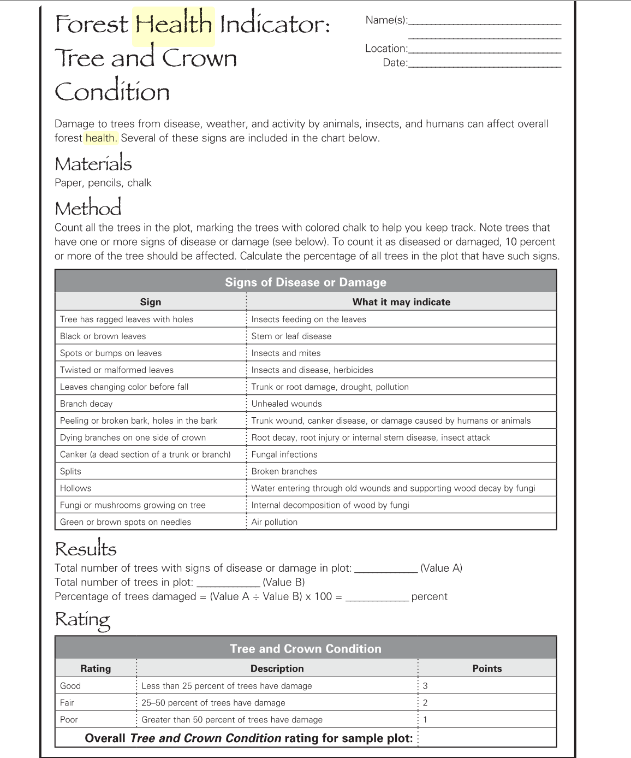
Appendix D: Monitoring forest health protocol forms developed by project learning tree
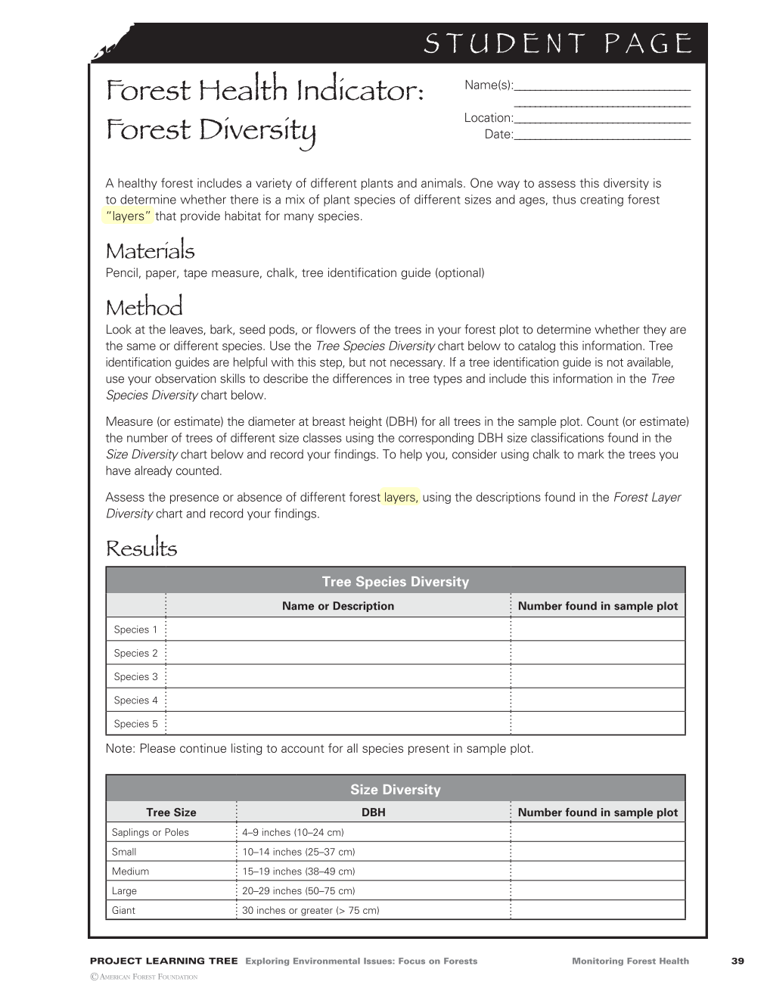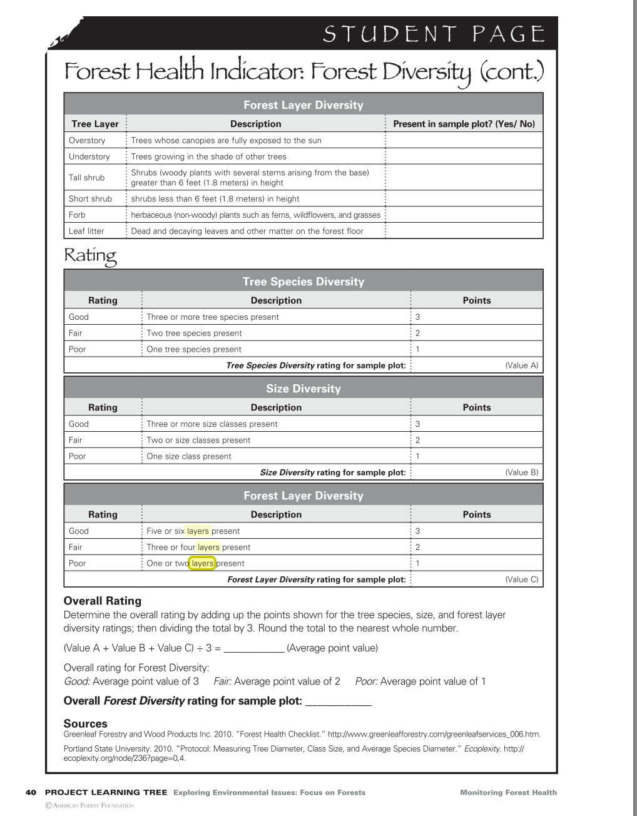

Appendix E: The three survey points where forest diversity and health were assessed during the 2021 monitoring visit
Categories | Kingsmill Forest Diversity Survey 1 | Kingsmill Forest Diversity Survey 2 | Kingsmill Forest Diversity Survey 3
Lat/Long | 44.713858, -76.230230 | 44.711778, -76.231873 | 44.712972, -76.230811
Size Diversity
Sapling/Poles | 1 | 0 | 6
Small | 1 | 0 | 4
Medium | 2 | 1 | 2
Large | 2 | 6 | 1
Giant | 5 | 5 | 2
Size Diversity Rating | Good – 3 points | Good – 3 points | Good – 3 points
Layer Diversity
Overstory | Yes | Yes | Yes
Understory | No | Yes | Yes
Tall | Yes | Yes | Yes
Short Shrub | Yes | Yes | Yes
Forb | Yes | No | Yes
Leaf Litter | Yes | Yes | Yes
Forest Layer Diversity Rating | Good – 3 points | Good – 3 points | Good – 3 points
Species Diversity
Species Present | White Cedar, Hemlock, Basswood, White birch | red maple, basswood, white birch, hemlock | Red oak, White pine, White cedar, White Birch, Basswood
Species Diversity Points | Good – 3 points | Good – 3 points | Good – 3 points
OVERALL RATING | (3+3+3)/3 = 3 GOOD | (3+3+3)/3 = 3 GOOD | (3+3+3)/3 = 3 GOOD
Disease Survey
Trees has ragged leaves with holes | 5 | 3 | 8
Splits (Broken branches) | 0 | 3 | 1
Total trees with disease | 5 | 3 | 8
Total trees in plot | 11 | 12 | 15
Percentage of damaged trees | 45% | 25% | 53%
OVERALL DISEASE RATING | FAIR – 2 POINTS | FAIR – 2 POINTS | POOR – 1 POINT

Appendix G: Property Restrictions

Conservation Land Tax Incentive Program (CLTIP)
Lady Kingsmill Nature Reserve has also been registered under CLTIP as a Community Conservation Land. CLTIP is designed to support private stewardship of important natural areas in Ontario by providing a 100% tax exemption to eligible portions of land. This program needs to be applied for every year in order to stay enrolled.

Land portions are not eligible under CLTIP if there are:
- buildings
- landscaped areas
- motorized vehicle areas
- areas producing timber or non-timber forest products for sale
- farmed areas
- areas with significant invasive/non-native species
- site alterations including draining, dredging, filling wetlands, aggregate extraction, grading and soil removal
*Engagement in the construction of the land use areas described above will also likely remove an enrolled portion of land from the program. Depending on when the land use activity started, the organisation may be retroactively charged for taxes.

Activities that maybe be permitted but require approval from the MNR include:
- tree removal
- trail development
- fuelwood removal
- culling non-native species that are minor component of the landscape.

Land use activities that are permitted include:
- low impact recreation activities (ex: hiking, biking, hunting, fishing, wildlife viewing)
- invasive species management
- prescribed burns
- trail maintenance
- tree felling/removal for health or safety purposes
- infill planting of native species representative of the ecosystem.

Ecological Gifts Program
Lady Kingsmill Nature Reserve was donated under the Ecological Gifts program as a fee simple donation. EcoGift donations provide the donor with significant tax benefits and a way for them to protect the ecologically significant land they’re donating.

Any change in use or disposition of an EcoGift property would need to be authorized by Environment and Climate Change Canada in writing. If a change in use or disposition proceeds without written authorization then the RWLT would have to pay a tax of 50% of the current fair market value of the property.

A request for a change in use maybe permitted if the change is beneficial to the long-term conservation of the ecologically sensitive features on the property. Changes in use are not likely to be approved if it is likely to diminish or present a threat to ecological features on the property (constructing trails or buildings, road paving or subdivisions). The disposition of a property will depend on whether the property is intended to be sold or gifted and whether the intended recipient is qualified to receive an EcoGift under Ecological Gifts Program.

